

**Santa Clara University**

**“CafeBronco”**

**Capstone Project Report**

**(Spring 2017 - Summer 2017)**

***Under the guidance of***

Prof. Michael Schermann

**Presented by: Team CafeBronco**

Dmitry Abramov, Garima Jain, Malya Jain,

Roopa Daga, Sayari Ghosh, Vinamrata Dake

**Table of Contents**

**Executive Summary** **3**

**Why CafeBronco? Problem Statement** **3**

Value Proposition 5

Uniqueness of the app 5

Competitive market 6

Financial/market viability assessment 6

**Project Scope and Decisions** **6**

Inclusions 6

Exclusions 7

**Learning Objectives** **7**

**User Stories** **8**

Actor: User (Students) 8

User Stories - Students 9

Actor: Vendor 9

User Stories - Vendors 10

**Technologies used** **11**

**Testing** **12**

**Xcode Snippets** **15**

Future enhancements 23

Rejected Ideas 23

**CafeBronco Team Profile** **24**

**Role Assignment** **25**

**Project Management - MS Project** **25**

Resource Sheet 26

Project Exclusions 26

Task Completion 27

Total Hours Worked 27

Out of Pocket Expenses 28

**Cost Overruns** **30**

**Deliverables enclosed** **30**

**Team Reflections** **30**

Project Promotional Video 38

Project UI Prototype (Before) 38

Project UI (On Marvel App) 40

Project Progress Updates 40

**References** **47**

# 

# 

# **Executive Summary**

With the widespread use of mobile phones, the usage of mobile apps has also become increasingly prevalent. If we take a look, we will notice that almost any business considers having a mobile app, in order to boost sales, increase brand awareness, promote loyalty and provide ease of access to customers.

Hence, we have came up with a plan to launch a mobile app for our fellow students by empowering them with food access at their fingertips and of course this project would be a perfect platform for us to learn new technologies as well as apply the knowledge we learned during the MSIS courses.

In this project, we have used development tools such as Xcode, Swift, Bluetooth Beacons, Apple Pay, QR Code and Google Firebase implementation. It also gave us us an opportunity to utilize our Software Project Management (using MS Project), System Analysis and Design (creating user stories), Database Management System (concepts used in Google Firebase) and Mobile Payment and E-commerce securities (Apple Pay and Beacons) coursework. We have also used the open source technology of GitHub as the code repository for version control.

# **Why CafeBronco? Problem Statement**

The idea of the CafeBronco came to our minds after having multiple unpleasant experiences for ordering food, while at the school. The team got together one day and started discussing about issues like ordering food while sitting in the class, just by one click and be able to pick up the order at the time of choice, discarding the long and endless queues. Hence, we thought it would be a good idea to initiate this as our Capstone project.

To better understand the views of students, we interviewed several students at Santa Clara University who regularly order food and asked the problems they face. The biggest challenge the students faced was that they cannot order food and have to stand in queues especially during peak hours. It becomes cumbersome for students to have food between 15 minutes break between consecutive classes. The students rather wish to order food at their own convenience, while sitting in the class and pick it up, say after an hour when the class gets over. Another pain area was that with some other apps, they can only order food to be picked up immediately Students often end up not ordering the food because of the wait times.

To know the other side of the story, we decided to interview the vendors to see the challenges they face. We interviewed Sandy from the Cadence Cyber Cafe in Lucas Hall. As per her experience, many times students forget to pick up their order or they get confused about the pick up location, or they pick the wrong order. The biggest issue for them were students not picking up the order at all, leading to waste of food or students picking up the wrong order, doubling their work of remaking the order. Students sometimes show up to pick up order in the wrong cafe. Meanwhile for the cafeteria staff, it gets difficult to manage orders when all students rush in together after classes.

We listed down all the concerns of the students and vendors and conducted a feasibility study. As per the outcome our study, we chose the CafeBronco app for our Capstone Project, so that students can order food in a hassle free manner.

We also realized that every great college has its mobile app swag, but SCU was lacking in this space. So we decided to put SCU on map with other great Universities by introducing SCU homegrown food ordering app - “CafeBronco”.

This app not only adds swag to Santa Clara University, but make life of SCU members easier. With long college hours, cafeteria forms an important part of every student / staff lives. During peak hours, the total time from ordering to receiving the food can be anywhere between 20 - 30 minutes. With CafeBronco app, SCU members will no more have to go through Tapingo’s (current food ordering public app) intrusive questions or wait in lines to place order. CafeBronco will be their one stop shop for pre-ordering food at a time of their choice.

## **Value Proposition**

To help solve the problems listed in the above section, CafeBronco app has been designed in such a way that it allows students to view status of their order. Secondly, along with status it will give details about the pick up location. And finally for order pick up, the app has a barcode scanner, which allows students to pick up the right order. It also helps cafeteria staff to manage staffing and schedules accordingly. For example: If students pre-order food just before their class ends, then the staff will estimate when to start making the order.

**Business Model**

## **Uniqueness of the app**

* CafeBronco is a dedicated app for Santa Clara University students. Because this is supposed to be official university app, users can be reassured that it is not collecting any personal data about them (the university probably knows much more about you already then any app can provide)
* The app allows students to view real time menu. This is useful when vendors use rotating menus
* The app also provides scheduled pick up functionality, which aims at helping both students and vendors to mitigate peak demand hours
* Through this app, the vendors benefit by knowing the demand for food depending on the order pick up times
* Vendors can also broadcast to students at the end of the day in case there is excess food, discount messages during low times
* Students on the other hand are able to place order and pick it up at the scheduled time
* This app allows students to make best utilisation of time in case they are pressed for time or just don’t want to bother standing in queue

## **Competitive market**

Tapingo is an existing food ordering app, not specific to Santa Clara University. It is not our competitor because the business models are completely different. Cafe bronco is a non-profit application that only caters to SCU whereas business strategy of Tapingo is to stick with multiple campuses particularly in urban areas. Only reason why we are studying Tapingo business model is because it currently monopolizes SCU.

* Tapingo works well because not all Colleges have dedicated apps.
* At Santa Clara University (SCU), Tapingo cut its first deal in 2012, over 80 percent of campus residents use it an average of 5.5 times per week.
* Also Tapingo collects a lot of information, which seems very intrusive for just a food app, but because of its monopoly users don’t have much choice
* Tapingo charges 10% for each transaction, whereas CafeBronco will be free of cost

## **Financial/market viability assessment**

* The CafeBronco app is a free app to be downloaded from the Apple App Store
* Currently, the application is being managed by software development enthusiasts
* As a future of the application, we shall minimal introduce premium subscription fee, so that the users can utilize more features in the application

# **Project Scope and Decisions**

## **Inclusions**

The following are the specific inclusions of the project:

* The focus of this project is restricted to iOS Mobile App only
  + iOS is a new platform and team wanted to learn the new technology of Xcode
* QR code provides two functionalities - students can use it to grab discounts and students can scan the QR code on the receipt and pick up the right order
  + The QR code is convenient to use for the end user
* The payment for the food would be done via Apple Pay only
  + It is the most secure way for payments. The card details are not shared and the payment is done only by fingerprint authentication. Hence, the app needs not be PCI compliant
* Google Firebase is used for as a database for backend integration
  + This is used for user authentication (students and vendors), fetching order details of the students and order change status from vendor side

## **Exclusions**

The following are the specific exclusions of the project

* Android development of the application shall be a future enhancement, however, has not been developed as part of this project
* Stripe Payment has not implemented for order completion for Apple Pay to reflect on Vendor’s side
* Any other forms of payments for orders has been scoped out of this project

# **Learning Objectives**

The team has achieved the following learning objectives while working on this project

1. Learn new technologies
   * The team was new to iOS and App development so creating an App required substantial amount of learning Swift, Xcode and Google Firebase. Along the development few extra pieces were needed for development and required additional studying (Apple Pay integration, bluetooth beacons)
2. Manage a real project - the Silicon Valley Start Up experience
   * This project experience has been very similar to a running the startup company, everything was new and unknown so we had to figure out all the aspect of the project (administration, coding, testing, technical documentation).
   * Business model part turned out to be much more complicated and resource consuming than we originally thought.
   * The team assigned different roles to members and worked as a start up team. Because we started to build our app from scratch we had to be learned all the aspects of a budding startup.
   * The team followed latest tools for project management i.e. MS Project, MS Visio, timesheet management, Slack and GitHub repositories, hence, gained a hands on experience on multiple technologies

# **User Stories**

Following user stories were developed as part of the project:

## **Actor: User (Students)**

CafeBronco should allow students to perform the following actions:

* Login using SCU credentials
* View personal information
* Place order from restaurants
* Enter quantity for the selected food items
* Provide pickup time for the order
* Grab discounts by scanning QR code
* View order summary before confirming the order
* Pay for the orders using Apple Pay
* Scan the QR Code of the order and pick up where there is a QR code match
* View order history
* Receive special notifications when in the range of beacons

## **User Stories - Students**

* The app will allow students to select a restaurant and place order with the required quantities of food
* The app will allow students to select pick-up at their preferred time and make in-app payment via Apple Pay
* The app will store order history and personal information of each student registered. Once the order is ready, order status in order history will change from ‘In Process’ to ‘Ready for Pickup’ and then student can pick up the order
* For order pickup, student can scan the QR code from the receipt and only the order match will show a QR Code success
* The app will send daily specials notifications to users by integration with Beacons which uses bluetooth technology
* The app will allow students to scan the QR code printed on the receipts on the order which will allow students to get discounts on their purchases

## **Actor: Vendor**

CafeBronco should allow vendors to perform the following actions:

* Login using SCU credentials
* View personal information
* Update menu items and prices
* View order details on a real time basis (as soon as placed by students)
* Update order status from “In-progress” to “Ready for pickup”
* Update daily specials in the system so that they can be broadcasted through beacons
* Collect payments via Apple Pay

## **User Stories - Vendors**

This app will help vendors to reduce operational expenses. It will allow the vendors to manage in- store orders and grow sales as less waiting time means more customers.

* The app will allow vendors to have access to database to update the restaurant details
* The app will allow vendors to view/update the order once the student places the order through the app
* The app will allow vendors to change the status from ‘In Process’ to ‘Ready for Pickup’ which will reflect in order history of student as well
* Once student picks up the order by matching the order QR Code, the status of the order will be changed to Completed, or else if the student does not scan the QR code, the vendor will update the status to ‘Completed’
* Vendors can update daily specials through app which would get updated in database and it will get fetched by beacons

**Project Approach**

* The first phase was finalization of the **Plan** and **Scope** of the project and preparation of the project proposal. For this, the team conducted extensive research work about the requirements and various technologies
* Second phase was the **Analysis** phase which included the research work on identified emerging technologies and studying about Xcode and Google Firebase.
* Third phase included **Designing and Development** of the code which included module design and specification, UI Design, populating database, writing the code for Apple Pay, QR Code and Integration of Beacons.
* Fourth phase included **Testing** of the different codes and modules in silos
* Fifth phase included **Remediation** of bugs and errors identified in the first test and re-working on the code. At this phase, it was ensured that all the requirements were being met. Further, it was also ensured that the security requirements are also fulfilled.
* Next phase included testing of the entire code which consisted of unit testing, system testing, integration testing and finally user acceptance testing
* The **User Interface** of the application was then advanced and the codes were implemented successfully
* Finally, the **Documentation** of the project and of each step was finalized.

# **Technologies used**

The mobile application industry welcomes new technologies and trends frequently. With no prior experience in mobile application development, this was a good opportunity to learn fundamental aspects. After completing some of the elective courses, team had gained enough insights required to develop this application with following technical approach

* **iOS platform -** The app has been developed for iOS platform
* **Swift -** Swift is the programming language used to develop iOS applications
* **Xcode IDE -** Xcode is an integrated development environment for IOS containing a suite of software development tools developed by Apple
* **Backend Server -** We used Google Firebase as a backend server to handle the real-time database updates between vendor and user. Firebase is a mobile platform that helps to develop high quality apps using complementary features. The data is stored in the form of JSON object
* **Payment through Apple Pay-** We integrated Apple Pay API to allow in-app payments as Apple Pay is the most secure form of payment
* **Beacons-** Beacons are devices that will help to send notifications using Bluetooth. Beacons were placed throughout the college campus and students could receive notifications about the special discounts and daily specials when they are in range of Beacons. We used Estimote Beacons
* **QR code -** Implementing QR code which students can scan to avail special discount offers notified by beacons. Also two way match of the QR code linking it to the backend server

**Technical Perspective**

* The team started with creating a MS Project for allocation work, managing day to day activities, determining budget, and setting timelines for the project. The team strictly tried to follow the schedule formed.
* The team learnt Xcode and Swift language for developing the application.
* The team created a prototype of the application on the Marvel application to get an understanding of the workflow of the application.
* After having a clear understanding of the requirements and workflow the team started developing the UI in Xcode editor. This was an iterative process as we tried to make the look and feel the best for the application.
* Once the UI was done the team concentrated on developing the backend database with Firebase. Firebase has been used to store and retrieve the data for the application. The student based login was done.
* Team integrated Apple Pay API with the application to set the payment procedure. This included calculating the final amount after payment after tax and storing the address of the student.
* Team implemented the QR codes technology for giving discounts using the QR code API
* QR code was also implemented
* Then the team focussed on developing the vendor side of the application integrating the vendor login and configuring the Firebase database for it.
* The team also implemented the Estimote Beacons for sending out notifications to students around the campus. The team use the API provided by Estimote for this integration.
* The team also used Github as the version control tool for managing the code base for developing the whole project.

# **Testing**

The testing was done in four different phases. The comprehensive test plan for project is as below:

* **Unit Testing:** Testing the program modules which perform specific functions in Xcode simulator. This testing made sure that module performs according to the program specification.
* **Integration Testing:** Focus on a set of program modules designed to operate together in an integrated fashion. Ensuring interfaces and program linkages, flow of data and program control, operate properly. This testing was done on simulator.
* **Systems Testing:** By performing System test, we ensured that mobile app meets the business requirement. This testing will help us to find how convenient the system is to use. This testing will be performed on simulator and mobile.
* **User Acceptance Testing:** Acceptance testing will be performed by Users with our support and will be test the acceptability of app to users. This testing will be done on User’s mobile phones.

**CafeBronco Flowchart**

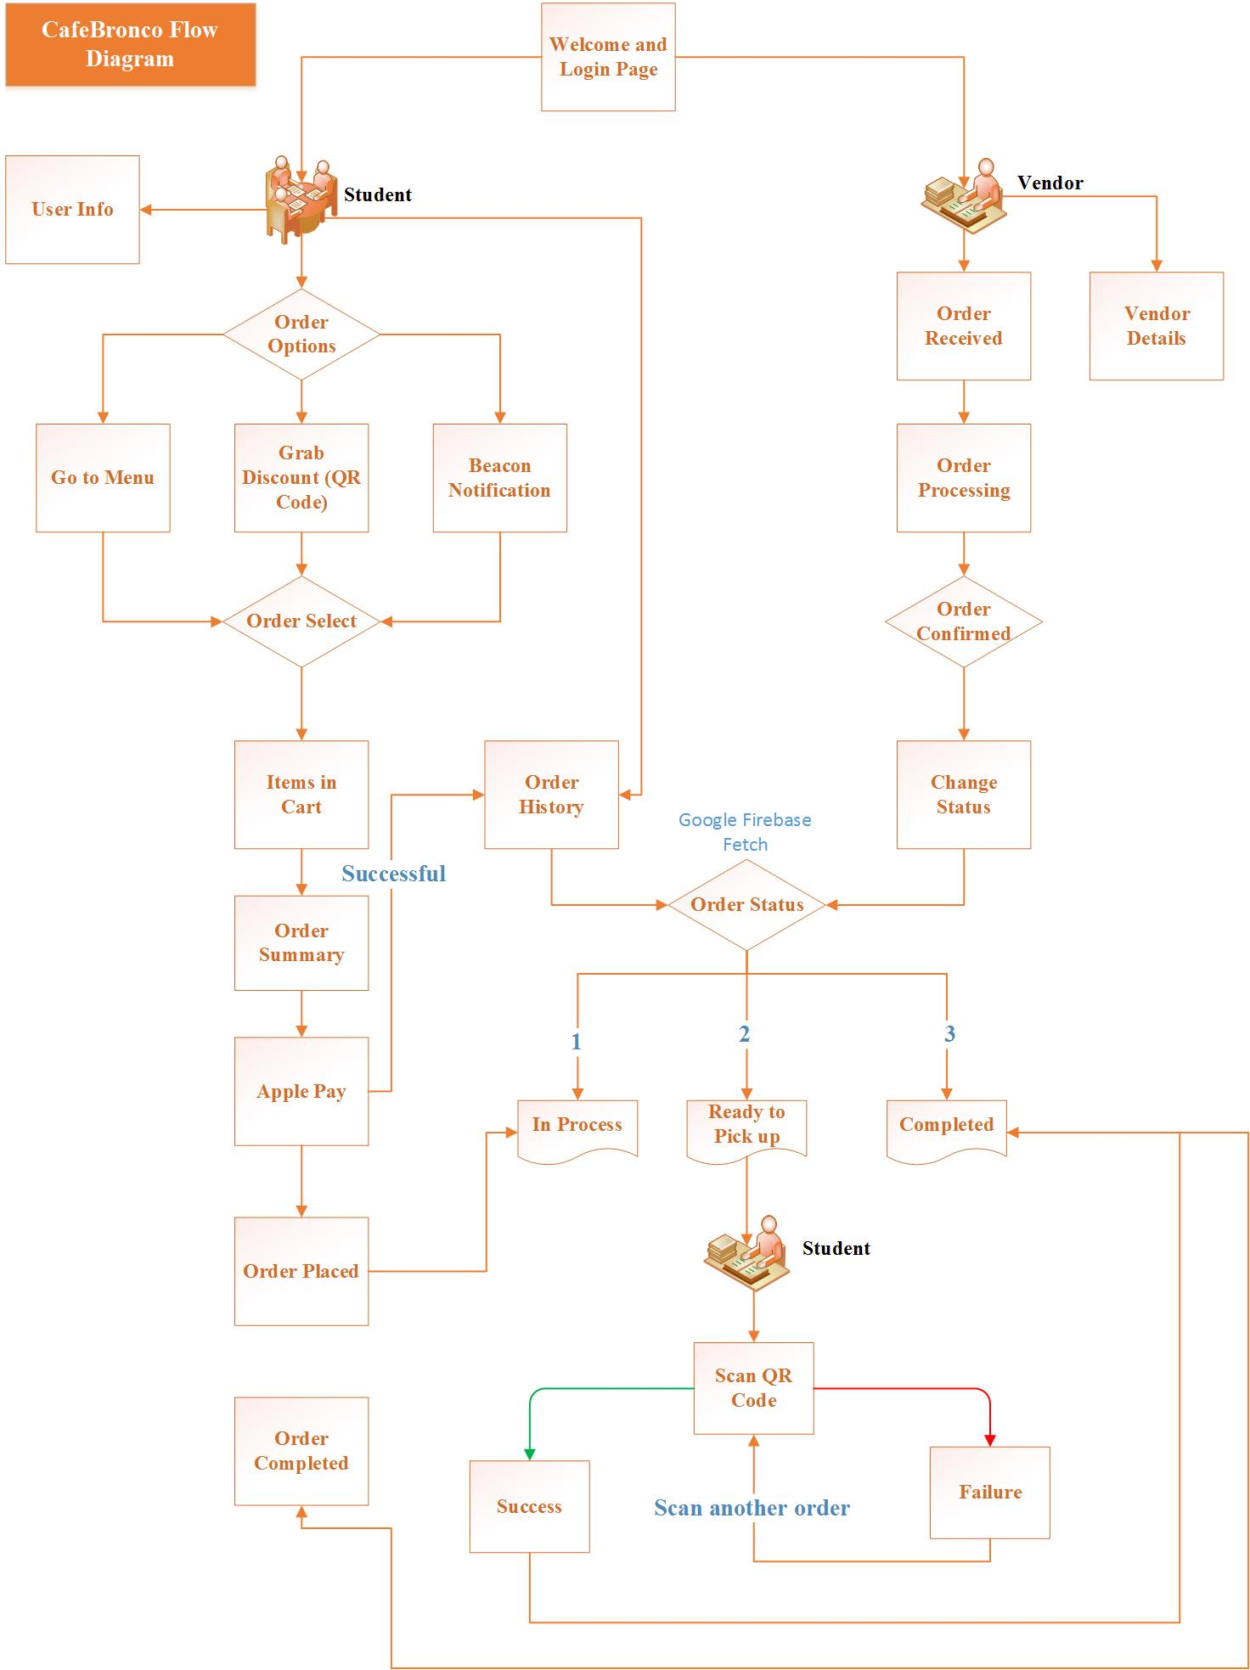

# **Xcode Snippets**

The API used for integrating Firebase is :

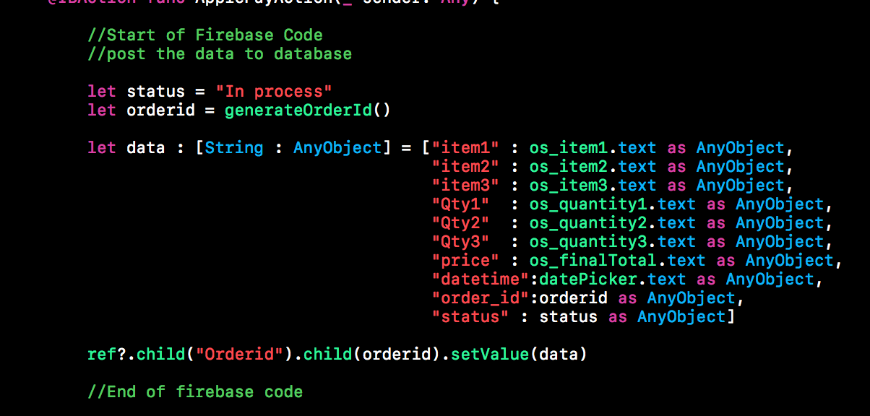

The API used for Apple Pay is :

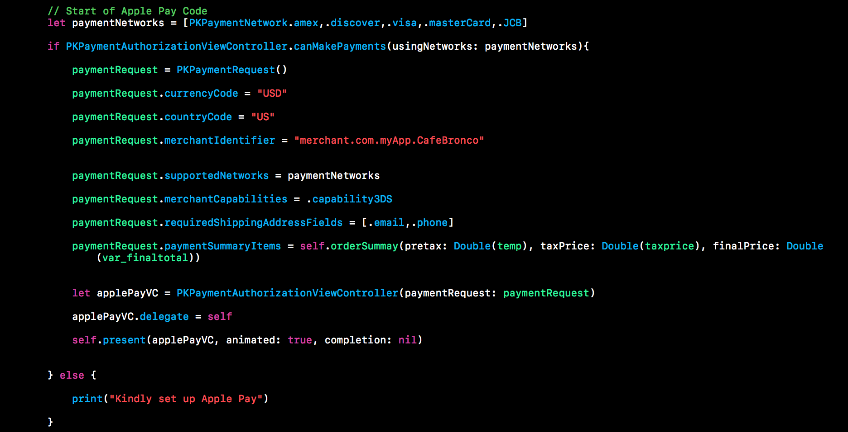

The API used for Beacons is :

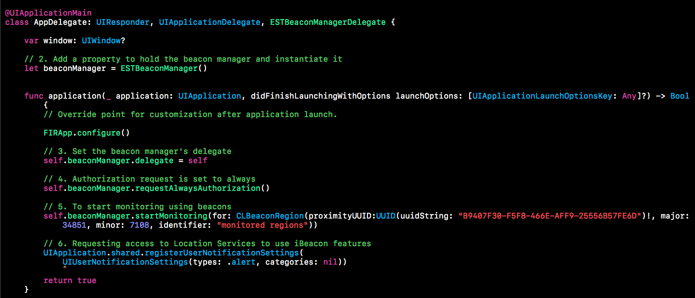

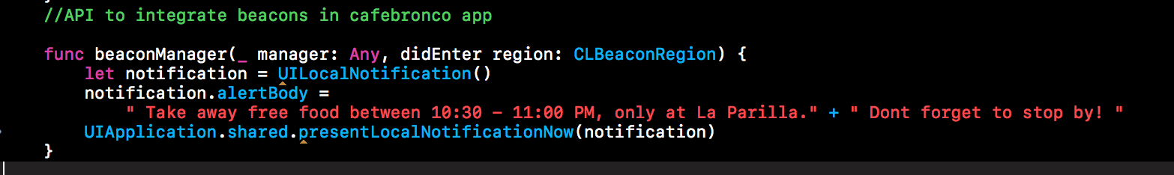

The API used for QR code is :

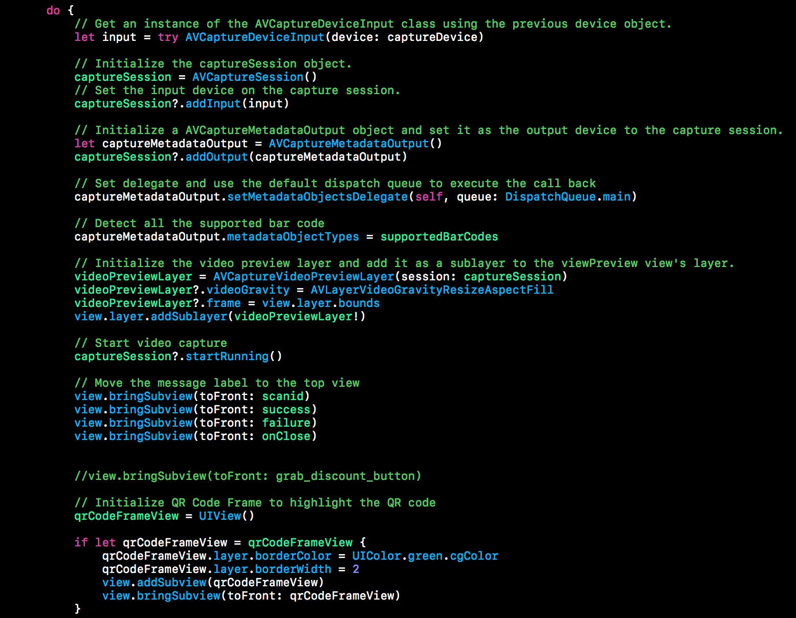

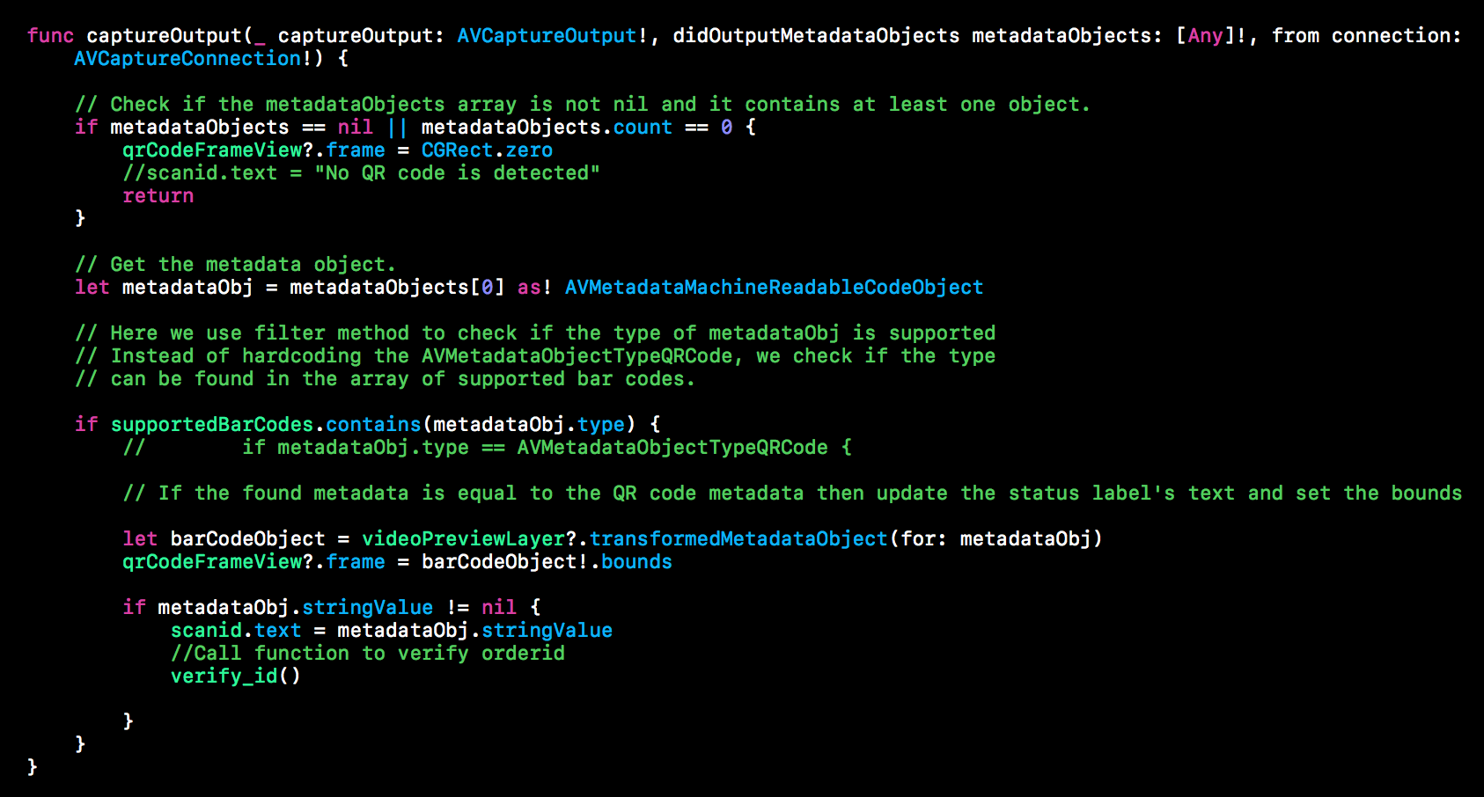

**App Screenshots**

* The user authentication is done via Google Firebase. In case the user enters wrong login credentials, an error message is displayed

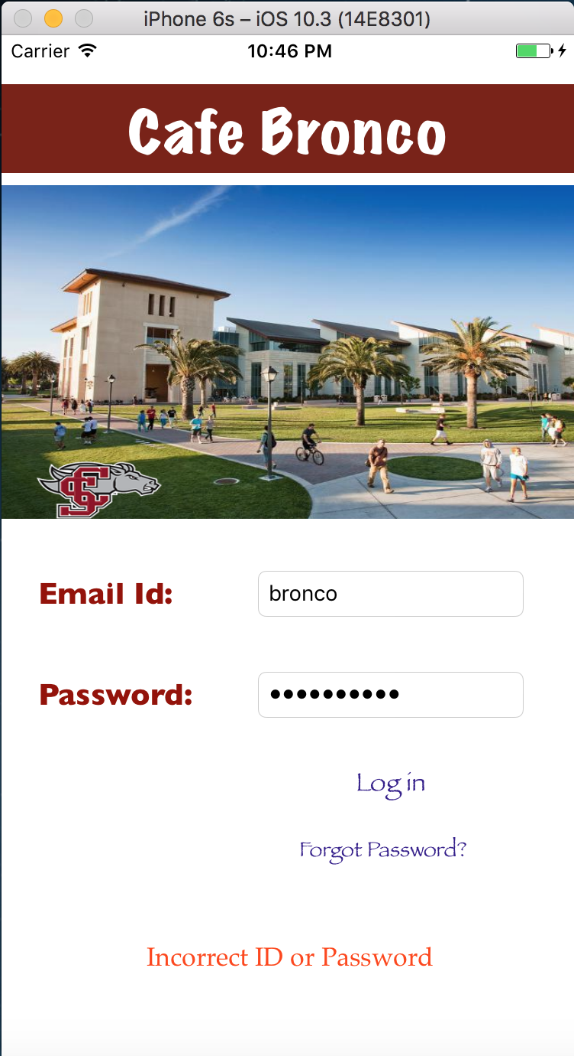

* This screen shows that the user has successfully entered the credentials, and hence would be able to log in to the app. The student can see the user profile.

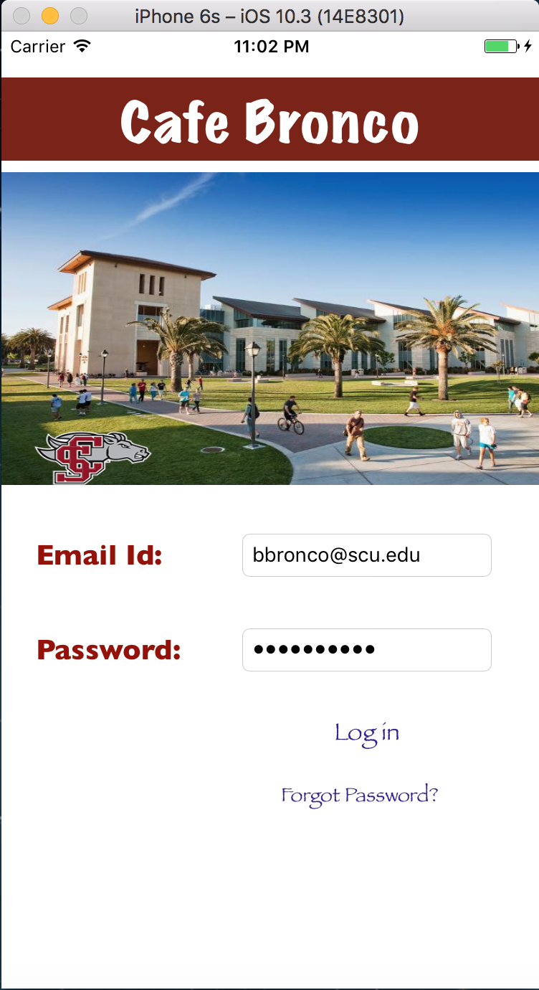 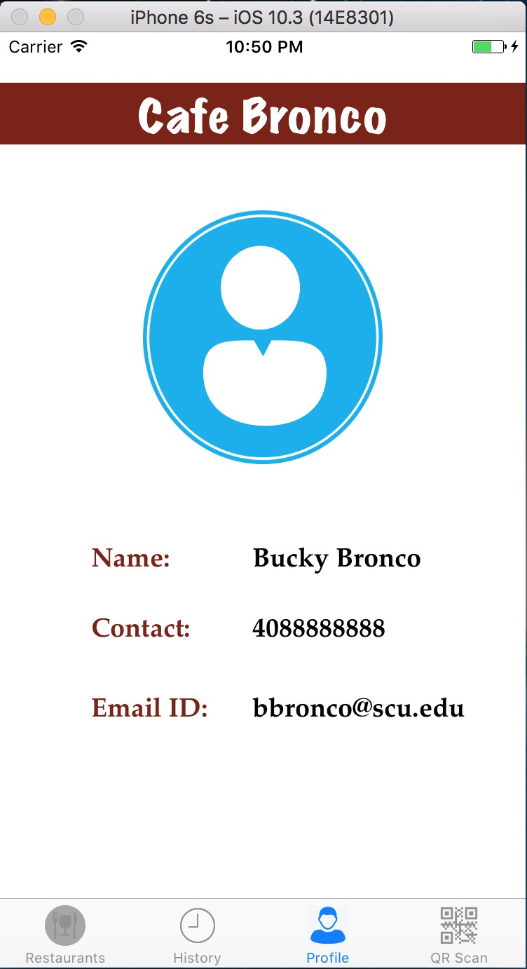

* After successfully logging in, the student sees the page to select the restaurant

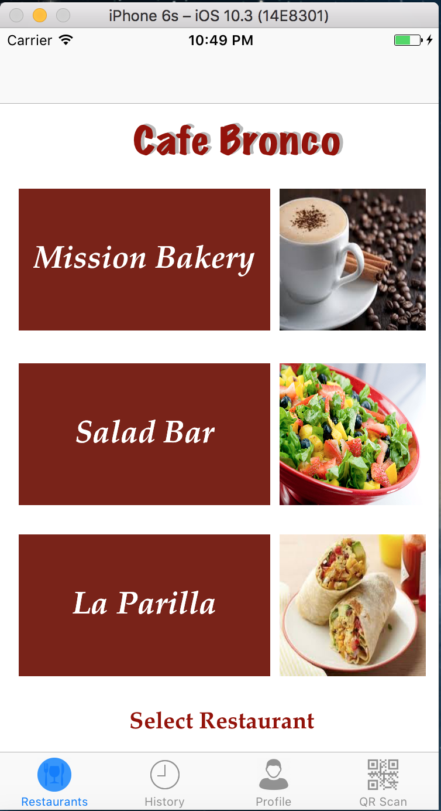

* The student selects the Mission Bakery and enters the quantity of food items from Menu

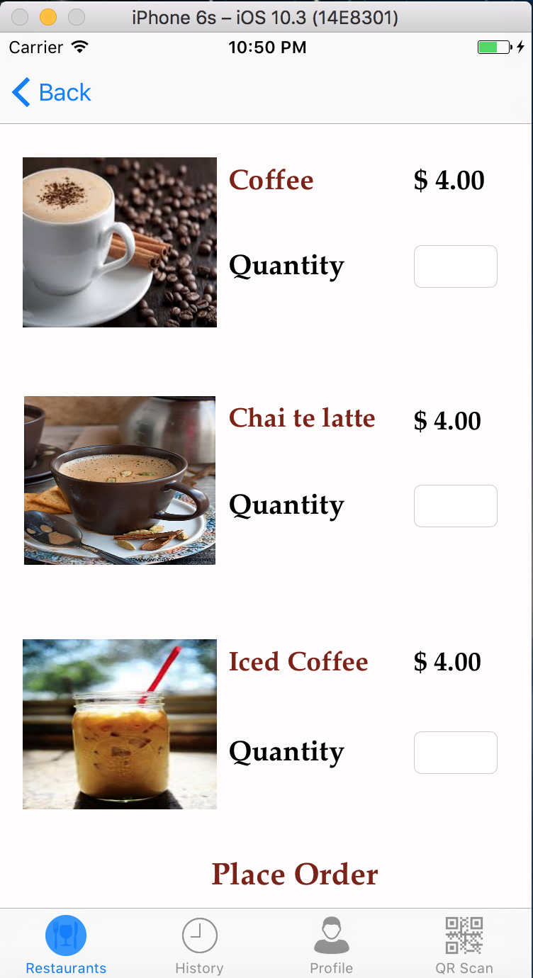

* Following are similar menu screens for Salad Bar and La Parilla

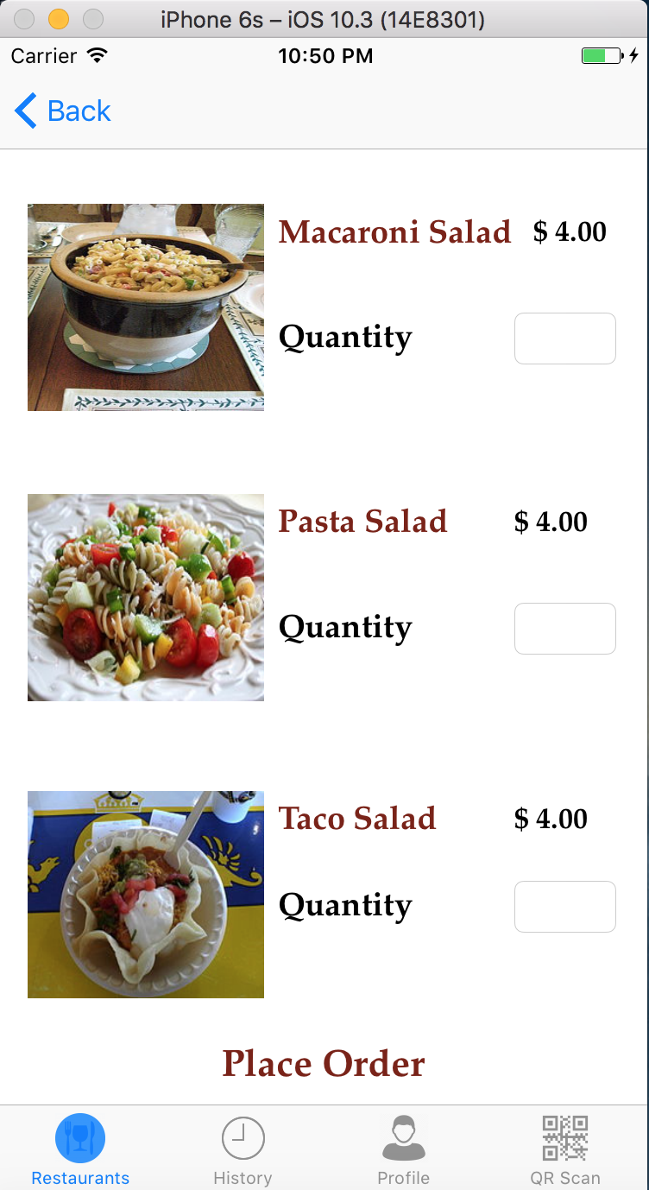 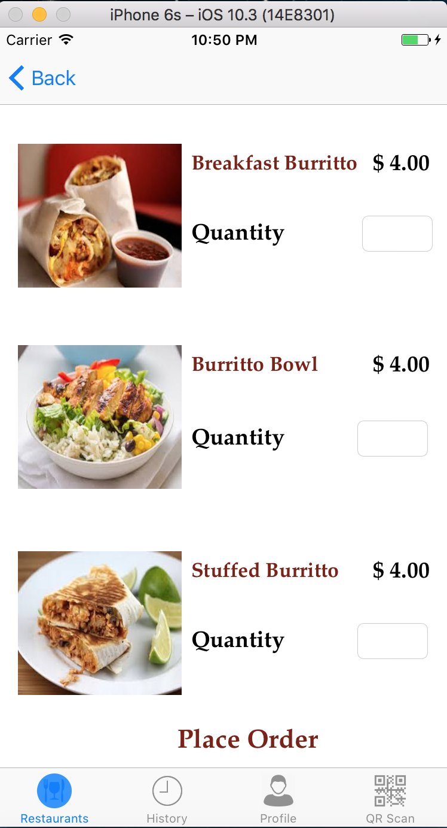

* The student selects the order quantity and selects the order pick up time and proceeds to payment via Apple Pay

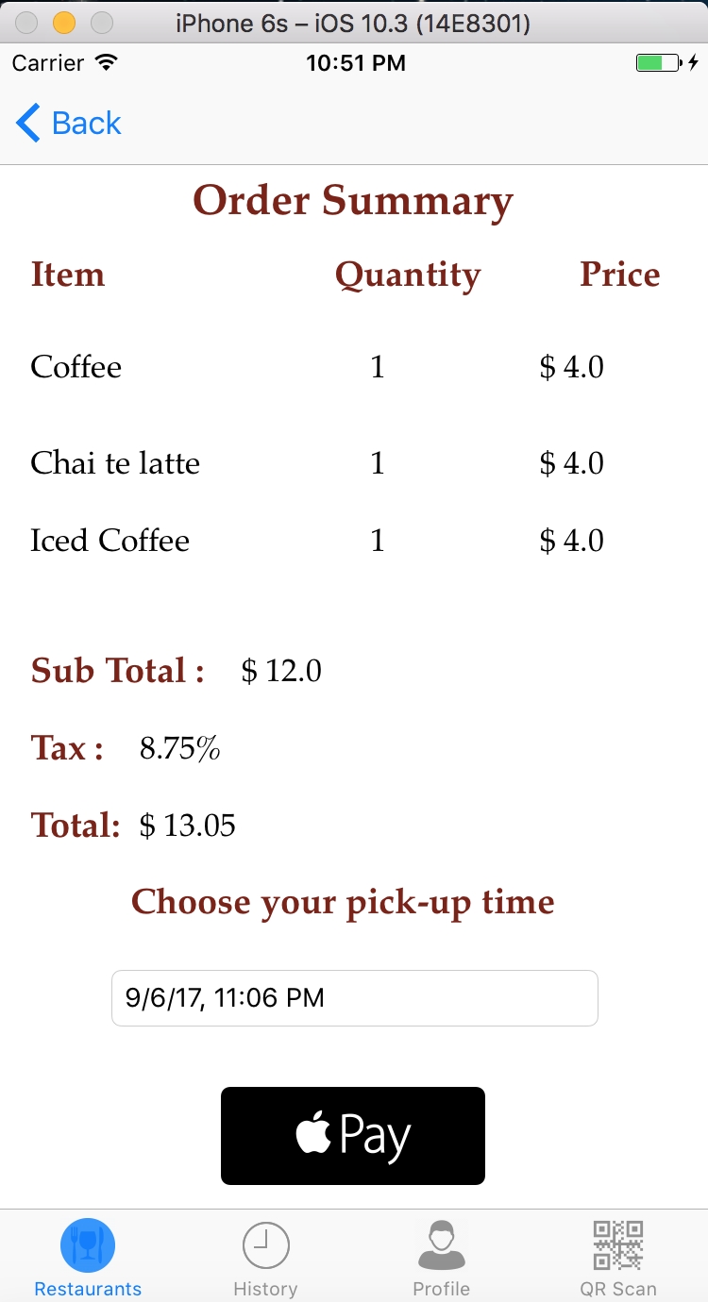 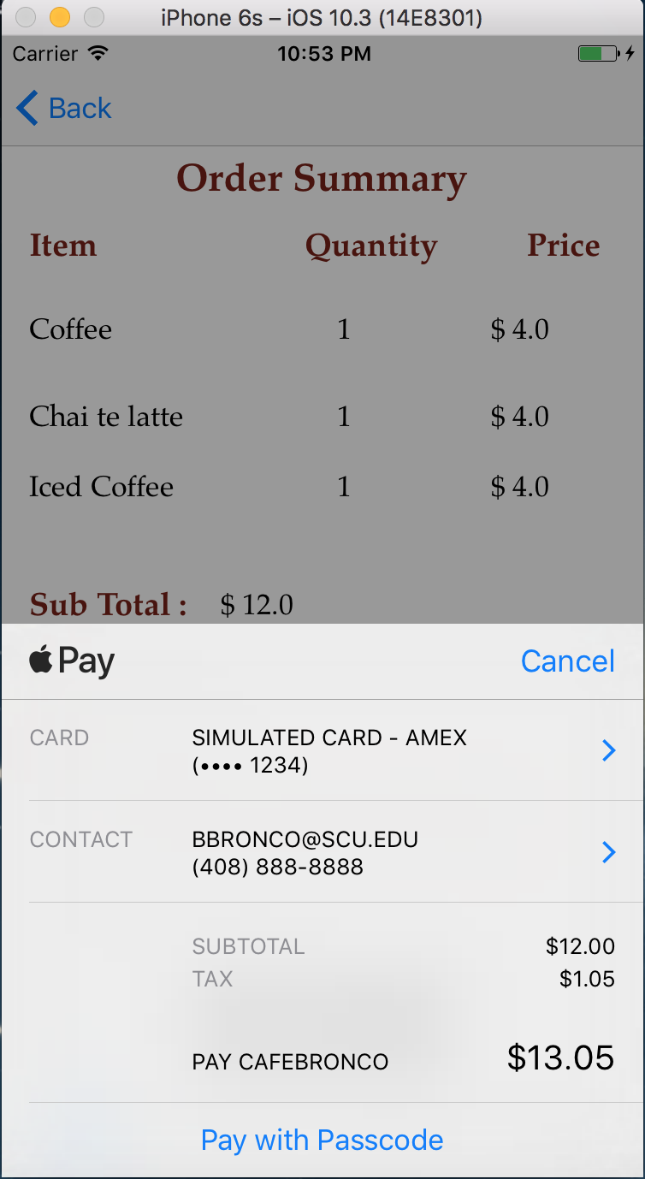 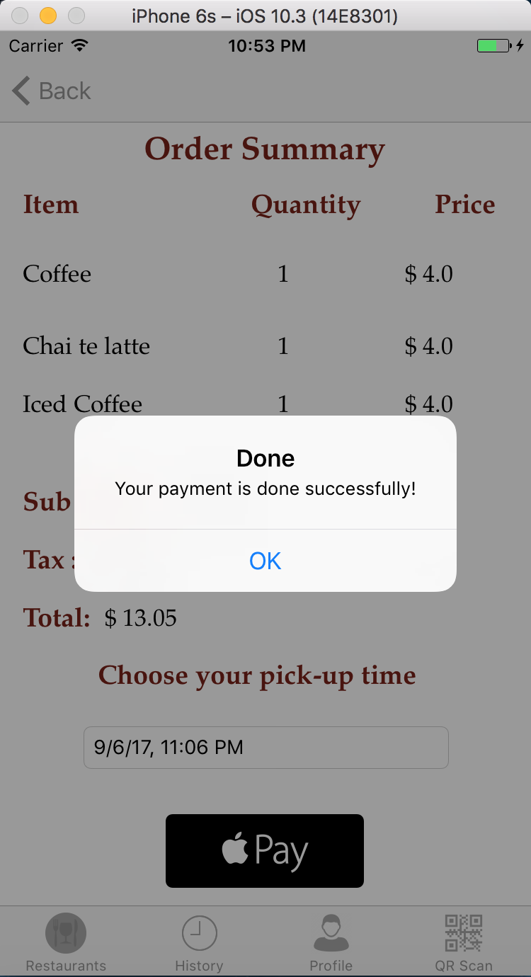

* Once the order is placed, it shows the status as In Process. Once the vendor changes the status, it changes to Ready to pick

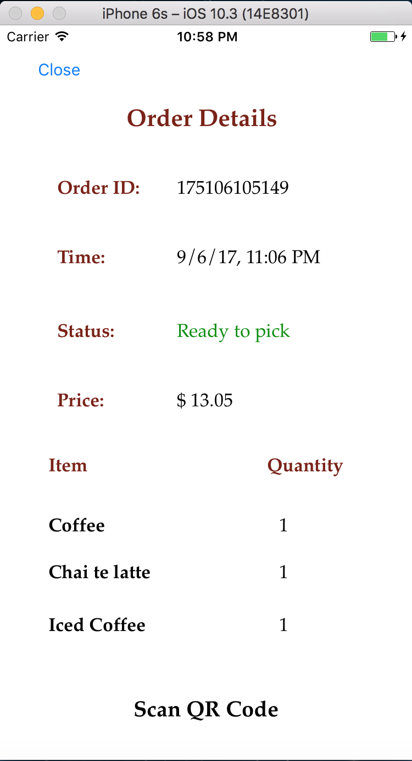

* Once the order is ready to pick, the students goes and scans the QR code printed on the receipt placed on the physical order. The first screen is on the vendor side. Once it is scanned successfully, the order status changes to Completed, as shown in the order history screen of the student

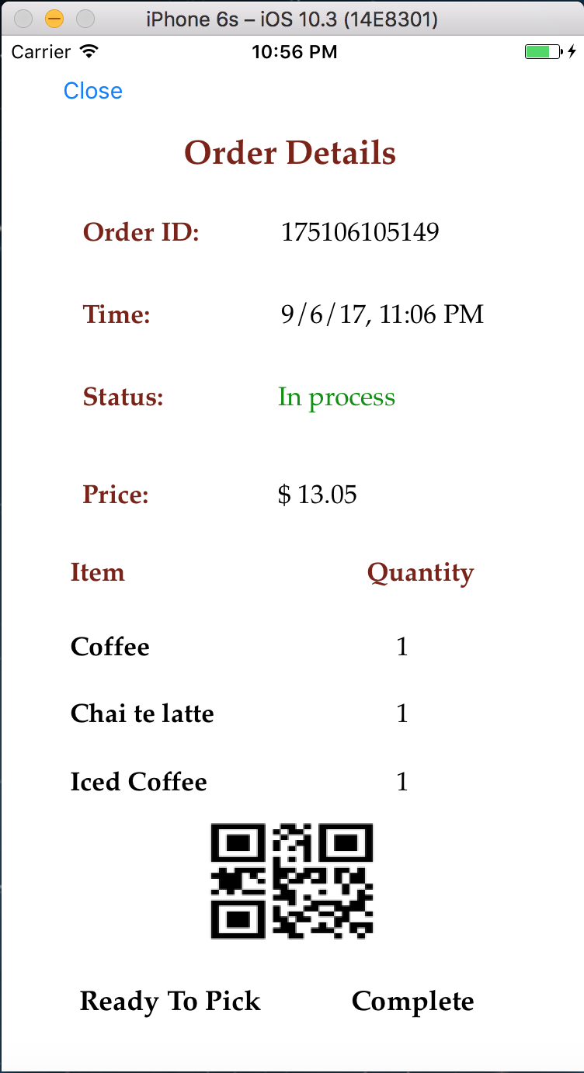 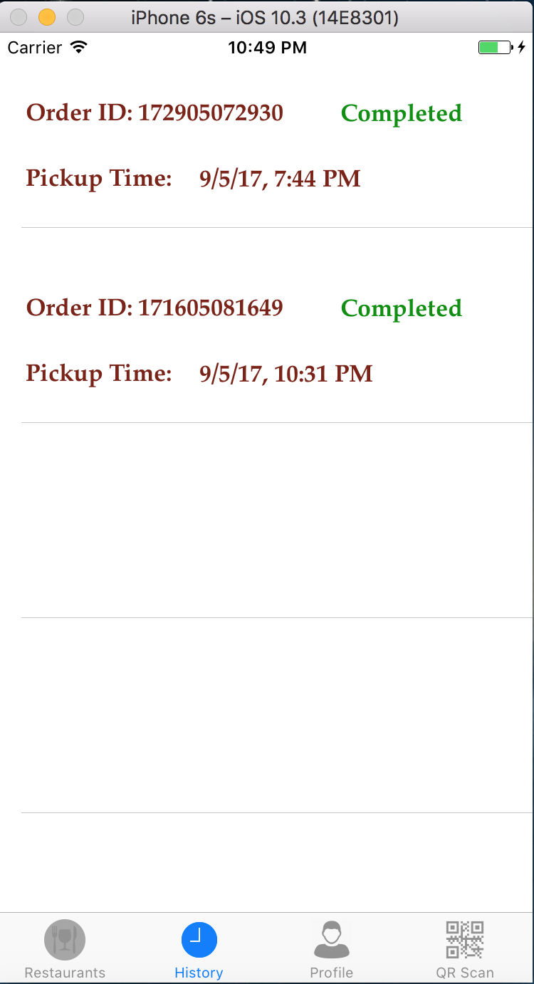

* This screenshot shows the notification of the offer that is being sent to the students’ phone, when in close proximity to the Beacons

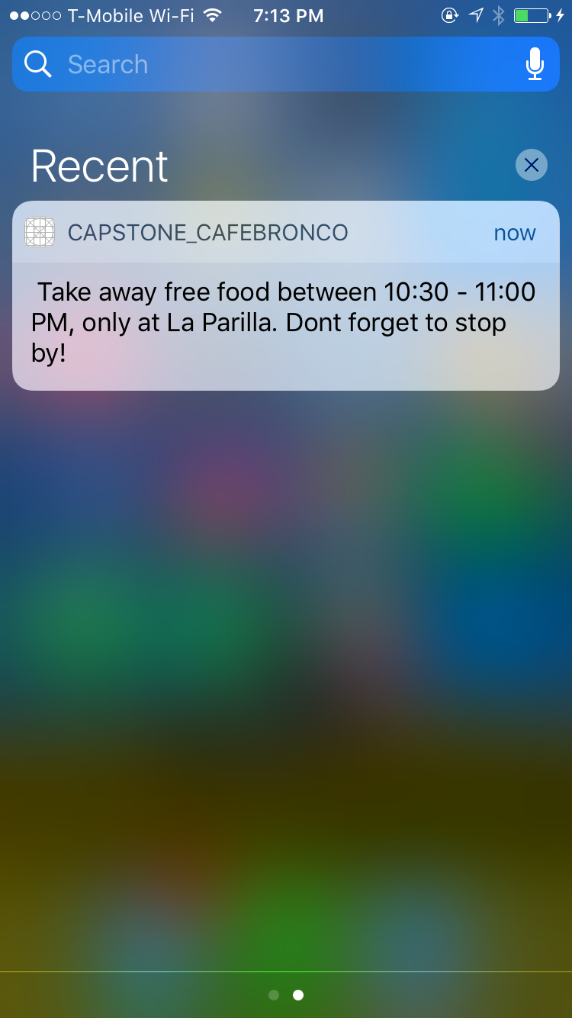

* This screenshot shows vendor login and profile screen

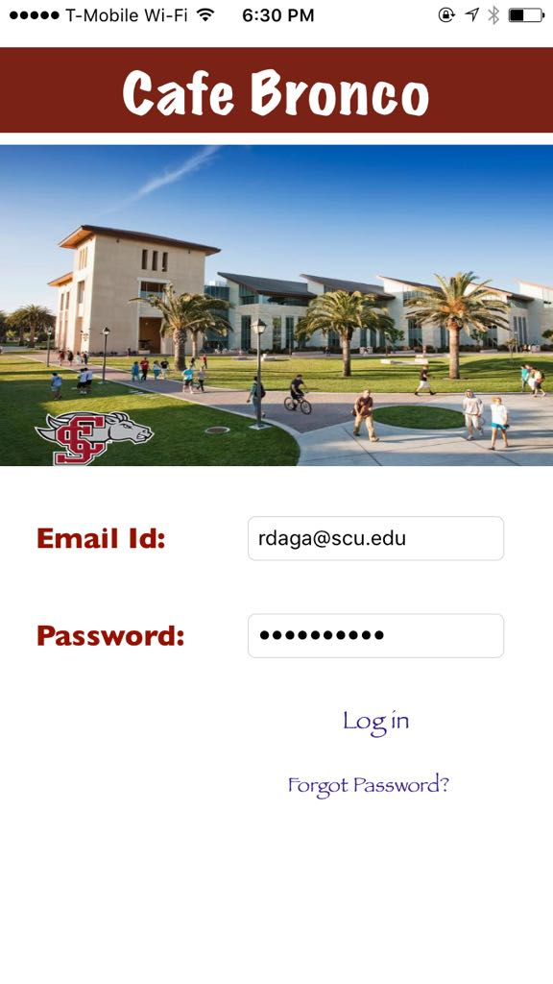 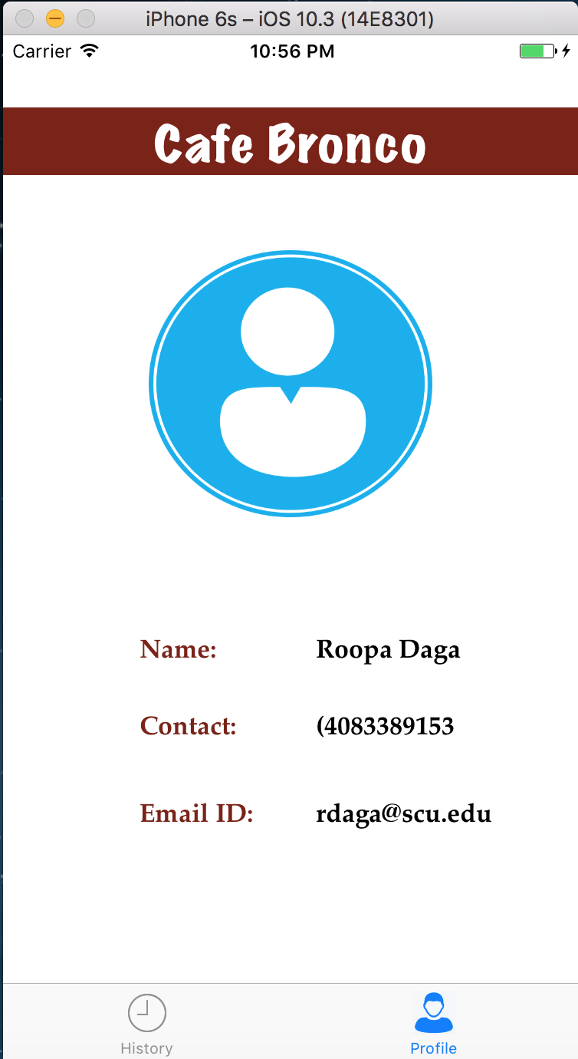

**Future** **Roadmap**

During the ideation process, the team noted down multiple functionalities to include in the application. However, while we proceeded with the app development, few ideas were not deemed feasible due to time and resource constraints. Hence, we decided that we can include some key functionalities in the future releases of the app and add those features and functionalities as future enhancements.

In this section, we have done an analysis of the key functionalities that we would include in the future releases. We have also included the key functionalities that are not feasible, hence discarded. It is important to note that some of the discarded ideas might come back on future improvement list for much later releases of the app if they become feasible. As the app enters a real world we expect to have users and vendors feedback, which will tell us what features we might have to add and what features we can take out if they are unused.

## **Future enhancements**

* + Introducing a premium service, which would be chargeable at a monthly rate to get premium features on the app
  + CafeBronco app will allow vendors to broadcast staffing requirements, which can be responded by students / staff looking for work or extra shift. The vendors can decide to either make hourly payments or provide meals to students in exchange for their work hours.
  + Functionality to send referral code to friends for discounts
  + Students can order together for a meal. For example, one student can order and split the money within the app. The second student won’t have to go through the process of ordering, he/she will just put the order number and pay via Apple Pay.
  + Vendors would be able to see an analytics page on the app for evaluating sales, prices, top items of food from different vendors

## **Rejected Ideas**

* + Instead of students coming and picking up the order, the employees working at the Vendor can go and deliver the food so that students save their time.
    - Rejected because vendors are short on staff and time as it is adding this feature will require some more planning and research so the user experience across all the vendors is uniformal.
  + Peak hours v/s weak hours
    - Rejected because it requires advanced algorithms and possible involvement of machine learning that is outside of the scope for the original development team.
  + Student can give rating/review to restaurant
    - Rejected due to the limited number of vendors on campus, although the feedback option is still considered to give an option to convey feedback to the vendors and give opportunities to improve.
  + Student can use university access card to make payment
    - Rejected defeats the purpose of Apple Pay and the secured payment mechanism

# **CafeBronco** **Team Profile**

**Roopa Daga**

* **Strengths:** Possesses strong programming and algorithmic skills with good understanding of database concepts. She has extensive experience in business technology, Agile SDLC, Testing and Technical writing with strong leadership and communication skills. She has strong analytical and problem-solving skills coupled with thoroughness and attention to detail.
* **Tech Stack** - Expertise in Databases such as SQL Server and MSSql

**Vinamrata Dake**

* **Strengths:** Possesses strong programming and algorithmic skills with experience in several technologies and environments. She has extensively worked on all phases of Software Testing Life Cycle
* **Tech** **Stack** - Knowledge of databases such as SQL Server, RDBMS, MongoDB

Programming language - Java, C#, PHP, Python, HTML5, CSS, Javascript

**Garima Jain**

* **Strength:** Possesses good understanding of business related problems, excellent communications skills, strong analytical & leadership skills and is a team player.
* **Tech** **Stack**: HTML5, CSS, Javascript, Ruby and Java
* Currently honing skills in Full Stack development and Analytics

**Malya Jain**

* **Strength:** She has solid writing skills and vast experience in information security field. Extensive past experience in Risk Consulting and Management Consulting. She has conducted multiple information security audits and application control testing.
* **Tech** **Expertise** - IT controls concepts and frameworks such as CoBIT, PCI, ITIL, ISO and SOX

**Sayari Ghosh**

* **Strength:** She possesses exceptional problem solving skills and expert in documentation. She has managed complete migration of multiple services while working in a banking domain migration project. She has designed and implemented Web Services.
* **Tech** **Stack** - SQL, Experience in working with different databases like DB2 and MSSql Programming language - Python and R

**Dmitry Abramov**

* **Strength:** He possesses strong business and project management skills. He has managed the IT infrastructure of a wholesale construction supply company.

# **Role Assignment**

**Project Manager** - Malya Jain

**Software Developer** - Vinamrata Dake

**Software and Database Engineer**- Roopa Daga

**Technical Advisor -** Garima Jain

**Tester -** Sayari Ghosh and Dmitry Abramov

# **Project Management - MS Project**

The project management was done via the MS Project tool. Following are some key dashboards and screenshots from MS Project

## **Resource Sheet**

The resource sheet consists of 6 members, with the hourly rate of $30 and an overtime rate of $40. The rate is competitive and is normalized as per industry standards.

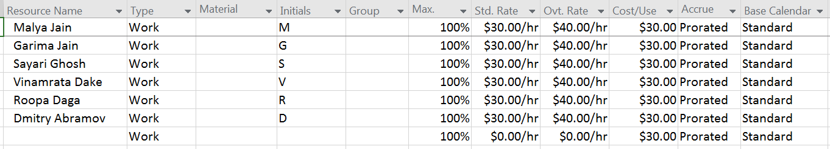

## **Project Exclusions**

This section includes the off times that the team took during the project. Such as break due to team unavailability, Spring Quarter final exams and national holidays.

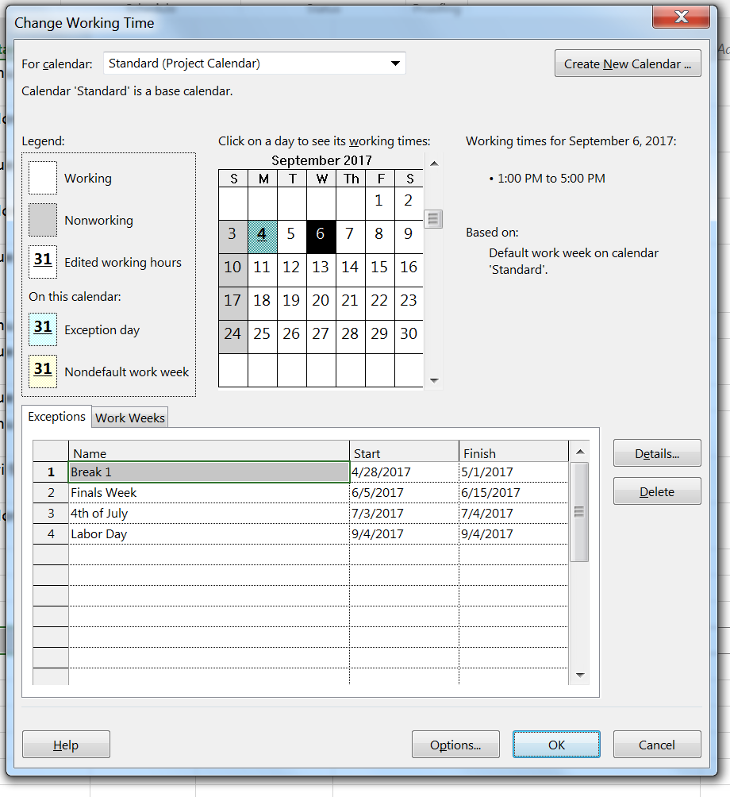

## **Task Completion**

This section displays all the tasks that the team had noted and followed

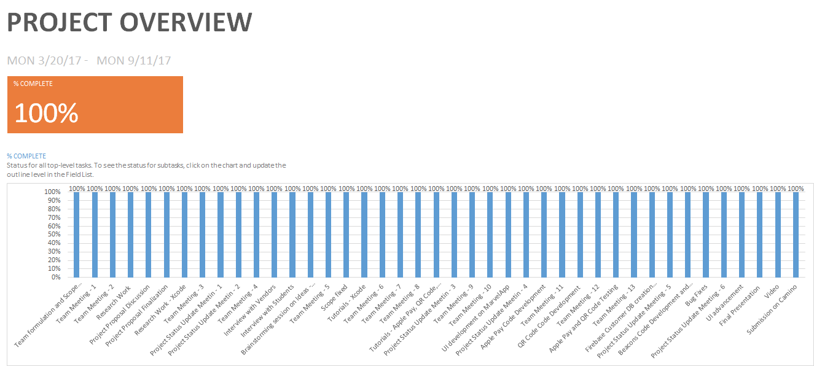

## **Total Hours Worked**

This report shows that the total hours worked by the team cumulatively is 1,192 hours. And also gives a breakdown of the actual number of hours worked by each member of the team.

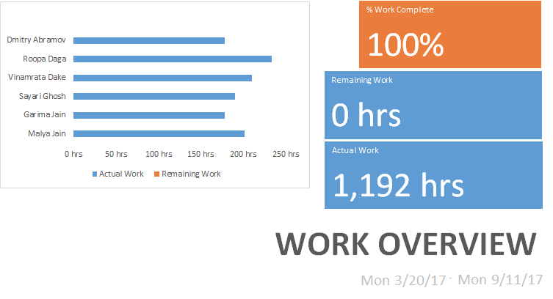

## **Out of Pocket Expenses**

This section contains expenses incurred in the project that were uniformly bore by all the team members. Below is a breakdown of the estimated expenses that will be incurred as part of this project:

|  |  |  |
| --- | --- | --- |
| **S. No** | **Description** | **Estimated Expense** |
| 1 | Apple Developer Account | ~$110 |
| 2 | Beacons | ~$90 |
| 3 | Miscellaneous | ~$200 |
| Total | | ~$400 |

**Cost Overview**

Based on the hourly rate and the number of hours worked by the team, the total cost of this project has come out to be $41,970. If the out of pocket expenses of $400 are added to this, the total budget of the project comes out to be $42,370.

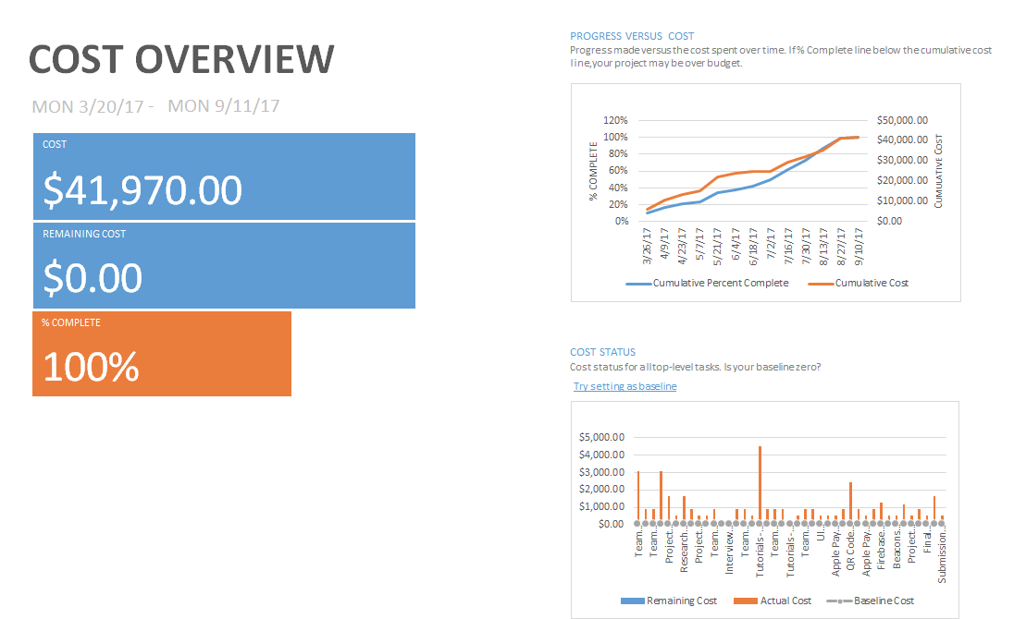 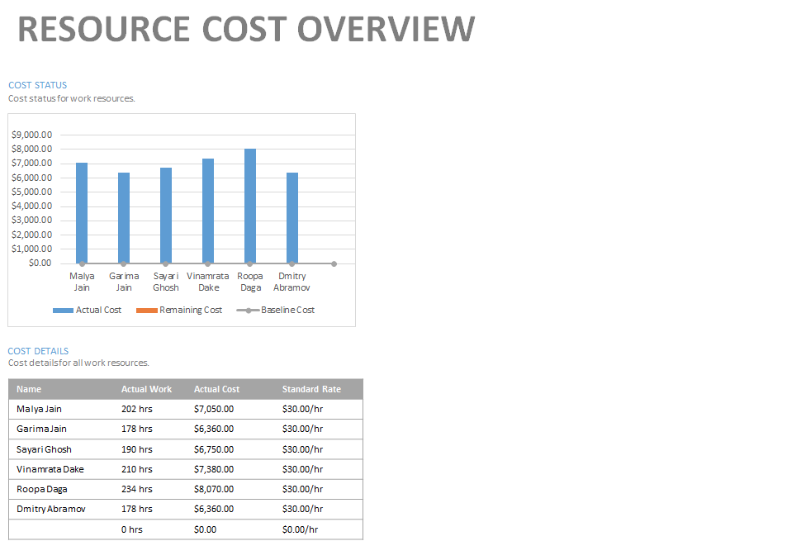

**Cost calculation per task**

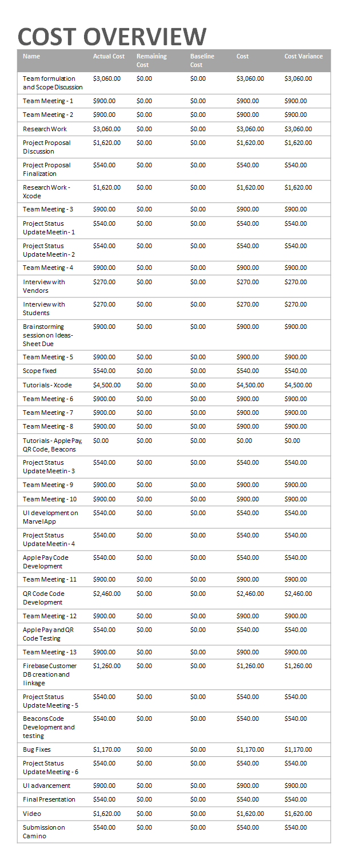

# **Cost Overruns**

This section contains the cost overruns per team member.

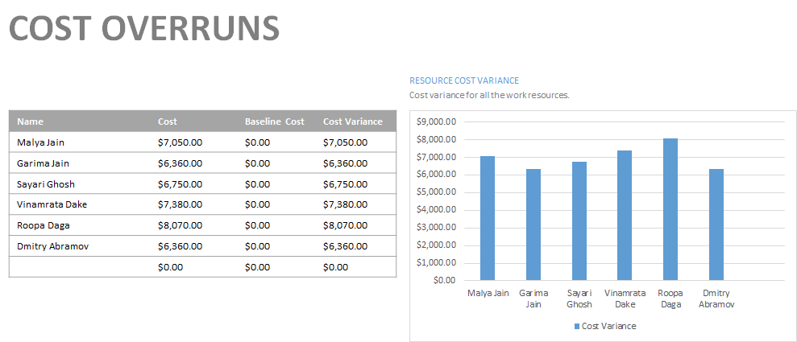

# **Deliverables enclosed**

* Project Report
* Test UI on Marvel App
* Xcode build
* Video

# **Team Reflections**

**Malya Jain**

This Capstone project was an ambitious one to start with. We as a team, wanted to make an app that makes the lives of the students at Santa Clara University easier. Our goal was also to learn the latest technologies and implement them in our app. The project started with high enthusiasm within the team. There was a flurry of ideas that came from each of the team member. Upon the advice of the Professor, we conducted an ideation session, where each team member wrote his/her own unique ideas that should be included in the app. Each team member could write any number of ideas, which may or may not be achievable. Then, a long session was conducted with each team member presenting his/her own ideas and other students voting on the idea, similar to feasibility analysis. This was a very interesting exercise. Since the scope of the app was quite huge, I as the Project Manager had a tough time to prioritize the tasks, maintaining the MS Project dashboards, ensuring that the project does not exceed the budget and also ensuring that I am able to study the Xcode, Google Firebase and all the associated APIs so that I can write the code assigned to me. I learnt a lot of skills as part of this project. The first and foremost was Xcode. With zero experience in Swift programming language, the team took up the initiative to create an iOS app. Because of this decision, I was able to learn and include this coding language to my skill set. Also, integration of the App using Google Firebase as backend was an additional value add to my skills. I would say, it was not at all easy to go about it. I saw endless online tutorials and multiple websites to identify the APIs that could go with our app. The biggest problem we faced was that all the help websites like stack overflow etc, gave the solutions to problems for the previous versions of Swift. The version of Swift upgrades at a very fast pace. The bug solving was very tough in this regard. Other challenges faced was the backend integration, because we didn’t want to hardcode anything. Overall, the final app turned out beautifully and I am glad. The most fun part was shooting the video. After wonderful feedback received by the Professor, the team was even more motivated to create a nice advertising video. The final words I would like to include in my self reflection would be that within these 6 months, I have grown my knowledge base and experience in such a tremendous way, that now I feel I am ready for my career in Silicon Valley. This project was just like a mini startup where everything had to be defined, designed and implemented by the team, along with overlapping ideas and disagreements, that were very constructive. With Professor’s tremendous belief in the team and trust he showcased, the team had full confidence that this project would be the most memorable one, and it was in fact the most memorable one for me. This project definitely pushed me out of my comfort zone and forced me to learn and implement the scope of the project. Looking at the deliverable now, I am happy that the push was totally worth it.

**Roopa Daga**

CafeBronco, an amazing and easy food ordering app was just an idea in our minds six months back. Advice from professor helped us to understand the business problems and initiate with the vision to achieve and implement our idea by writing everything on paper and discuss the feasibility. Overall this project gave me the flavor of how real world projects operate. When we started initially, all I cared about was the implementation and technical part and based on that, I would come up with the use cases. But professor gave us the right direction to forget about the technical details and come up with the proper planning and design of the app from business perspective. I also learned that any project is not only about the implementation of the product but resource planning, training, cost and time management are equally important.

Training and time management was the most challenging part of the project. Starting with zero knowledge of Xcode, Swift etc, most of my time went in learning Swift and it was sometimes very painful to remember all at once and I had to read documents and watch videos repeatedly. Thanks to online tutorials and youtube for the best basic tutorials on simple topics. Slowly I got hands-on with Swift language and I started enjoying Xcode and Swift language. We as a team would learn different topics and share with each other, which eventually helped all of us to get the grasp of it.

Once we started gaining confidence with simpler topic, we decided to move towards the more complex topics based on our use cases. Hence began the real trouble. We as a team divided our work into different modules, I was leading the integration of Firebase database module. The challenging part of the project was to connect to the database and implement the real-time connectivity within the app. The online tutorials and videos helped me to understand how to setup and connect to firebase. Since our use cases were complex, it took us a while to figure out the efficient ways to fetch and retrieve the data in Json using firebase and swift. But at the end, all the time spent was worth it when we achieved what we wanted. In parallel, we started exploring on API’s to integrate Beacons, Apple Pay and QR Code functionality. Since Apple deprecated many of the syntax and functions in Swift, we faced many challenges to fix minor errors too. Another challenging part of our project was to implement different screens for Vendor and Customer and display accordingly based on the login credentials. As we moved forward, we solved all the issues with great effort and hence enriched our learnings every day.

Trust is the main factor when working in a team and professor trusted us and gave us the flexibility while working on the project. The trust amongst the team members motivated us and helped to overcome all the hard stops of the projects. The fun and most memorable part of the project was video recording at the end. Professor taught us project management skills, technical skills, time management and at the end he asked us to make the advertisement video appealing others to download our app. This helped us to think from the Sales and Marketing perspective and come up with the best possible advertisement with the limited resources.

There are many future enhancement scope in this project which we were not able to complete within the timeframe like user registration, end to end real time connectivity with backend, security, rating the food items and restaurant, searching capabilities.

This project overall was the great team work and one of the best studying experiences so far in SCU. It helped me to figure out my strengths and to fight my weakness. I would like to thank Professor and my team mates for the incredible learning time.

**Vinamrata Dake**

These six months of capstone project has been a great learning experience. Initially we all wanted to do something that would be useful for SCU students. After multiple discussions we finally decided to create a mobile application for SCU cafeteria. Then the question was which platform to choose between Android and iOS. With team’s interest we chose iOS and we had plenty of things on our plate! We had to get acquainted with Xcode and Swift programming language. Before that it was important to understand what problem we are trying to solve. Initial phases such as planning and analysis which includes collecting requirements from SCU cafeteria staff and students, understanding the current food ordering system and defining the business model were challenging. As a Software Developer, the designing phase was more difficult as none of us had previous experience in mobile application development. We referred many online tutorials to learn Swift programming. Major challenge was connecting with Firebase database. With traditional database engines such as SQL server, you can insert and fetch data with single query, but in Firebase, one SQL query is equivalent to few lines of code. After great efforts we finally achieved data flow between application and backend server. For Apple Pay and QR code integration, we used online APIs. But understanding and implementing those APIs in our code was bit tricky. The error messages and exceptions we got during back-end development were hard to decode. So we referred Stack-overflow discussions to solve those issues. Thanks to our professor who suggested one more interesting use case of QR code that is order confirmation for vendor side. We discussed few approaches for generating QR code and automatic status update on QR code scan. After working on Xcode over the past 5 months, we understood how data flows within multiple view controllers, so we implemented that feature successfully. Another interesting thing I learnt was bluetooth operated beacons which are easily configured to send out notifications. We were able to incorporate feature to attract students by notifying them about special deals in cafeteria. During this project, along with technical skills, I acquired project management skills as well. I believe when you are working in team, trust is very important and we all had it amongst ourselves throughout the project. This has been a great team work, we assigned roles to everyone, divided tasks so that each one would contribute, defined a schedule, completed individual work on time, helped each other and tracked the progress with professor during weekly meetings. Overall this project helped me realize the areas where I need to focus more in programming. It feels great that we successfully converted our ideas into reality.

**Garima Jain**

The Capstone project deeply enriched my learning experience. Initially I had no coding nor project management experience, but now I feel confident in these skills.

We started the project with the aim to improve the SCU experience. We wanted students to have the comfort of food availability anytime without having to waste any precious time waiting in long queues.

The main learning points in this project were getting to learn the business as well as the technological aspects. We learnt Xcode as a platform, Swift as the programming language, learnt how to integrate third party Api’s in our app and integration of database with front end. This project also taught us about pair programming, importance of team dynamics and project management.

These learnings were achieved through multiple online tutorials and varied documentations. Major challenges were integrating third party Api’s and firebase with front end. Hours were spent going down a rabbit hole on StackOverflow for debugging purposes or scouring through documentation for resolution. But after all the hard work, the result was sweet, We were not only able to achieve our MVP (Minimum Viable Product) but even stretch goals like Beacons and QR code.

It feels great to have accomplished our vision for this Project and this would not have been possible without our team.

**Sayari Ghosh**

The past six months have been an amazing experience from being a novice to an intermediate in application development. We as a team had aimed high and took a bit of gamble when we decided to go for doing the application development in iOS. But it was a very fulfilling and enriching experience. Initially we had focused only on the technical aspect of the application, as we wanted to learn and implement new technologies. But after having discussions with the professor we started thinking about the business aspect of our application. This helped streamline our thoughts while we started designing our application.

Our goal was to give back something to SCU and this CafeBronco application was apt for this. Initially I had no experience in project management and in iOS application development, but this was a great learning experience for me. Firstly, we had allotted random hours and timelines for our application. But soon we realized that we had to follow the deadlines properly in order to succeed. We brainstormed a lot on the business aspect of our application and also spent hours learning the new technologies like Xcode, Swift, Firebase. This was the planning phase where we had a layout of how our application would work and created a prototype using Invision application. This helped us in creating a structure for our application and helped us clear our thoughts.

Then when we grew more confident of our application and our skills in developing the application, we started by creating the screens for our application. As the full workflow was already finalized it was a easy task to do. The most challenging part was setting up the Firebase database. We spent hours debugging, watching YouTube videos and going over stackoverflow to solve the issues we were facing in integrating the Firebase to the application. Storing and retrieving data from Firebase was a real challenge for us as we required nested json object for that and we could not find relevant examples online. Apart from this we started to work on the comparatively easy parts such as Apple Pay, Beacons and QRcode. The Beacons was the easiest and as API are easy to integrate with Swift and Xcode. But while developing the QRcode was a bit challenging and inputs from the professor really helped. We tried to keep up with our created timelines but whenever we missed a few due to our technical limitations, we as a team made sure that became high priority for us and we worked extra hours to make up for it.

The whole Capstone experience was wonderful. Right from developing an application from scratch to managing a real project. Another thing that this project taught me specially was team work and strengthen our bonds. The most fun part though was making the video and promoting our application. I am glad that I was a part of this CafeBronco application.

**Dmitry Abramov**

The whole capstone experience was very surprising to me from beginning to an end.

At first the idea seemed very simple only technological implementation part seemed a little bit hard and work intensive. However through the process I realized that that project carried much more additional aspects that were not clear in the beginning.

Going in we didn’t really have any business model, we just wanted to make an app to make life easier from our perspective. However we didn’t realize that there was more to it than our own perspectives. The end users and other stakeholders will have their own and before we proceeded we needed to make sure that we know what those are. Following professor’s advice we conducted few interviews of vendors and students. Turned out we were missing out on huge functions of the app. For example making sure user picks up correct order, or vendors being able to send notifications to alerts students on deals available on foods that are need to be sold today or be thrown out.

Next big surprise came when we calculated our time spent on the project and evaluated the costs. At the beginning we completely neglected cost of our own time. However when at the end of the project we calculated the cost we were shocked at how high it was, so we lower our labor cost to industry minimum but still came out pretty high. Also it is worth mentioning that the cost is just for a prototype app, making market ready app will require even more resources. Without solid business model or other form of funding (ex: SCU funding) it is very had to recuperate the cost in near future.

The managing of the project also is a process that we didn’t think would be a big issue; however all the small upkeep items added to sizable amount of overhead just to manage the project.

From technological point of view we knew it will be hard but development of the prototype took much more time than we originally thought. I think other team members who were closer to development will talk about it in their reflections but basically there was a lot of things that should have worked but for some reason didn’t. In general xcode and swift are not as easy to use as it claimed by Apple. Creating even a simple click through UI was pretty complicated and clunky. So I had to do the UI design in Photoshop and then transfer it into Marvel (UI mockup platform) just to have something to look at. Marvel platform in my experience was a little too basic (just link overlays over images). What was even more surprising, I wasn’t able to find a platform that offered some degree of UI programming (adding text input fields emulating user input, doing basic calculations, interactive messages, etc…) without being way too complicated.

At the end I think that I have learned a lot for this project. We were able to complete the project on time and I think CafeBronco is a success!

**Appendix**

## **Project Promotional Video**

<https://youtu.be/VEk7n99yE7g>

(Best viewed in 720p quality and full screen)

## **Project UI Prototype (Before)**

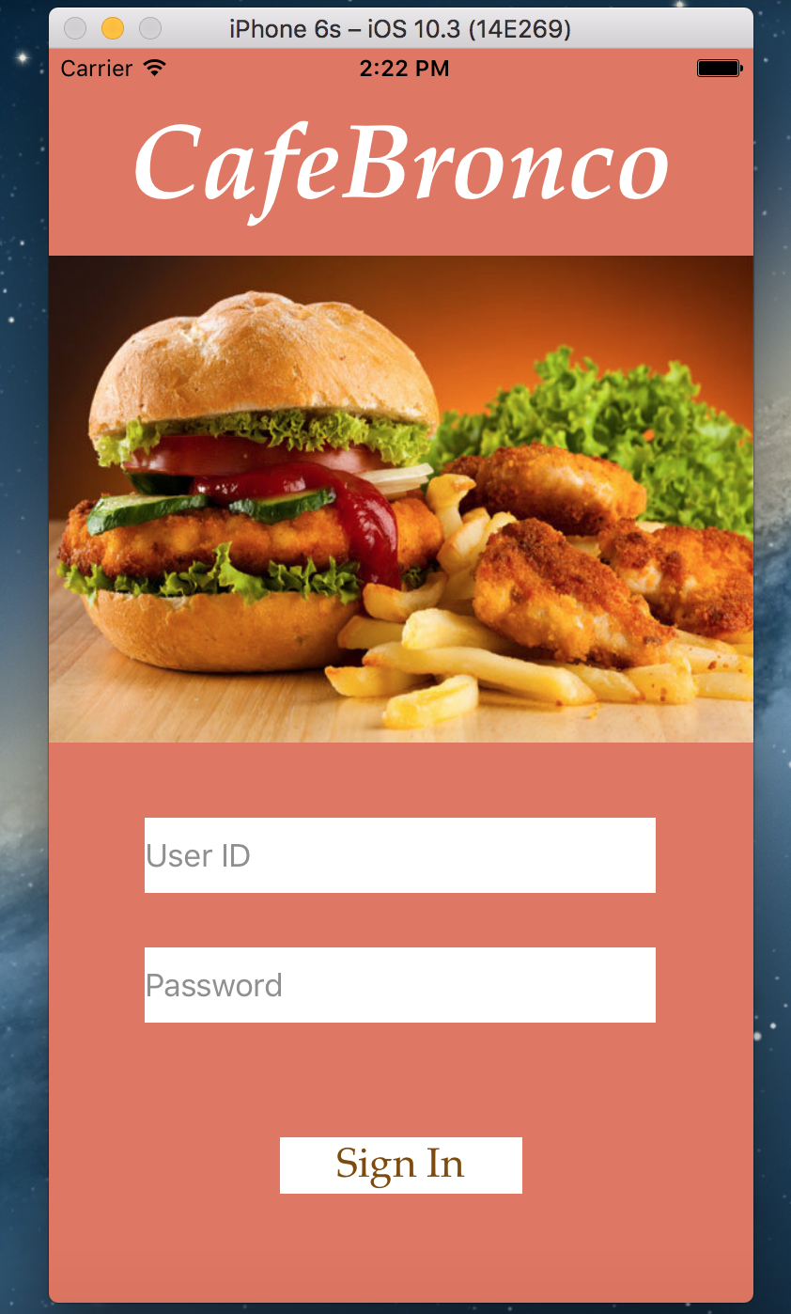 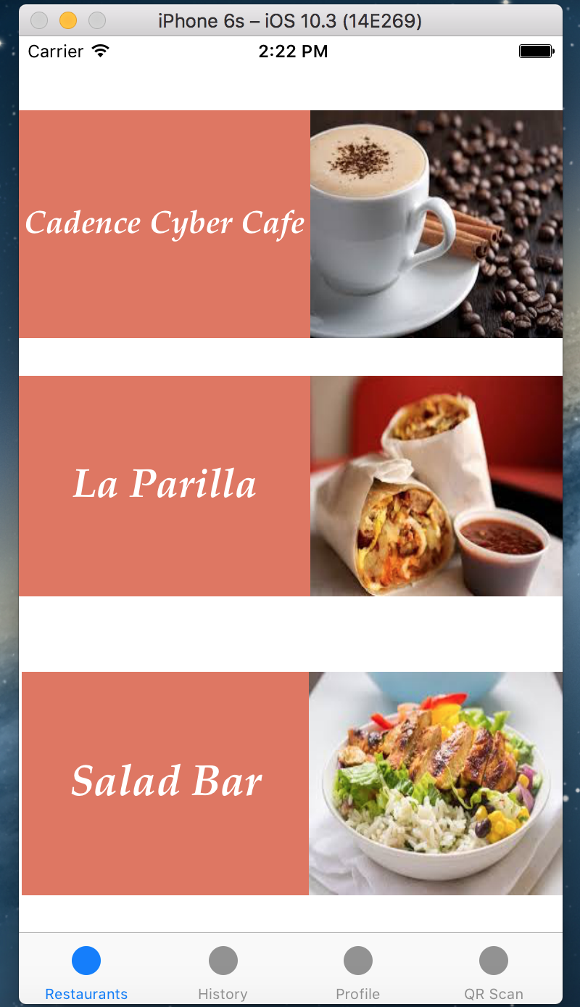 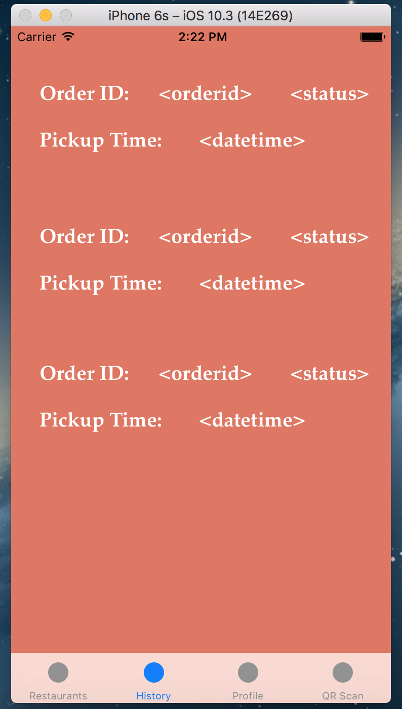

**Log In Screen List of Restaurants Order History Screen**

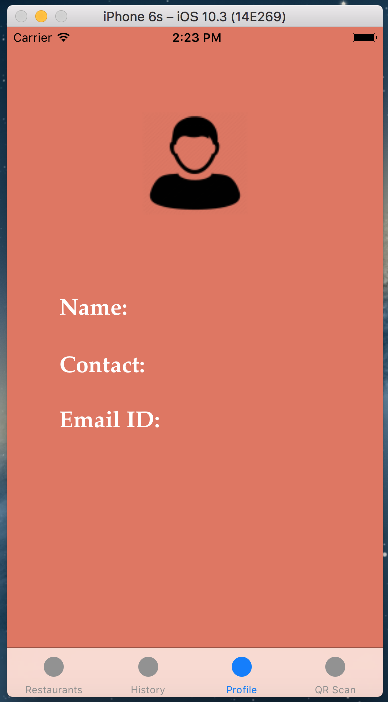 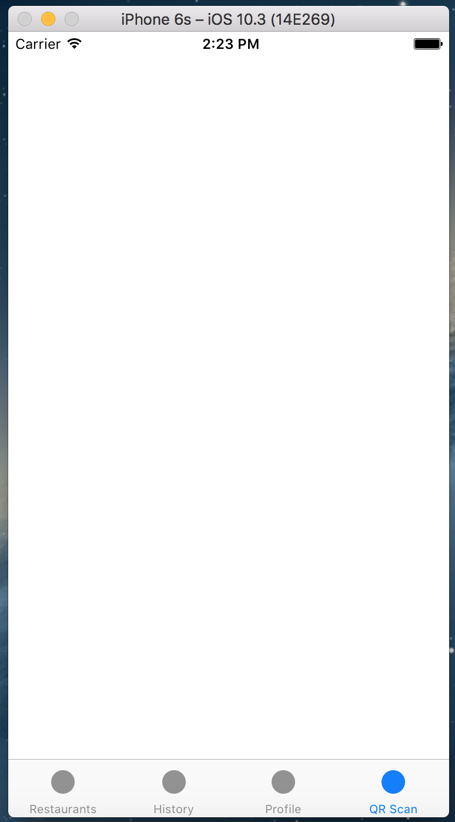 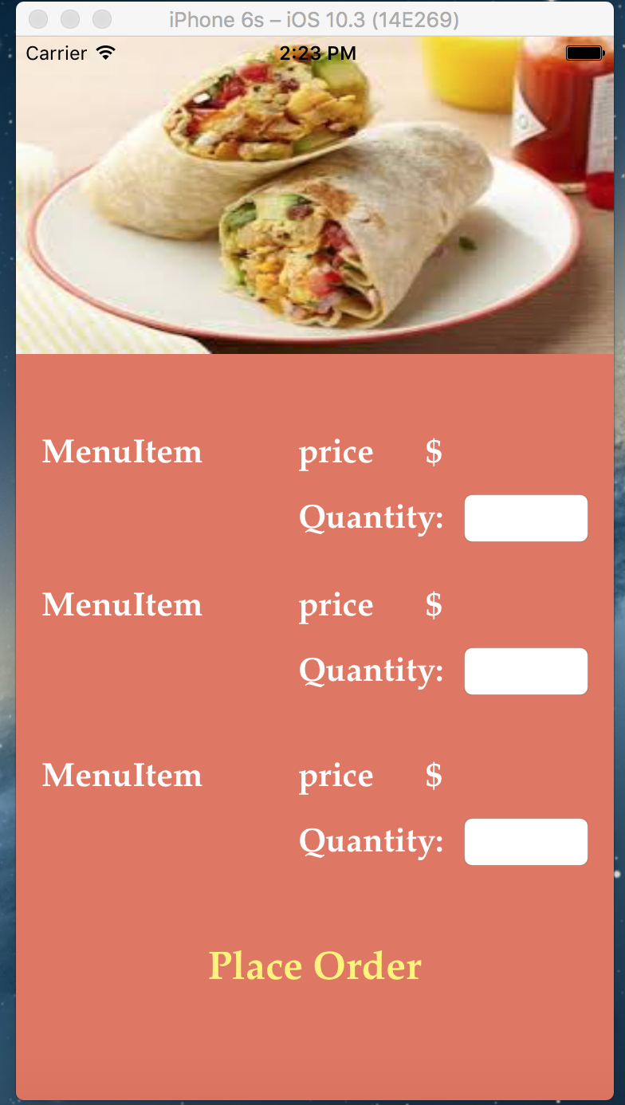

**Profile Screen QR Screen Menu Items Screen**

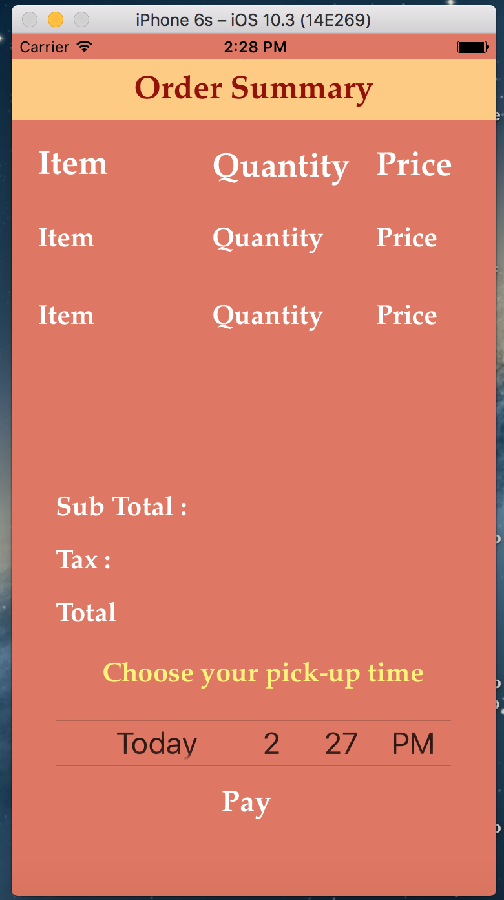

**Order Summary Screen**

## **Project UI (On Marvel App)**

The UI test screens that were created are located on the following link:

<https://marvelapp.com/if78076>

## **Project Progress Updates**

* 1. **Project Progress Update (04-25-17)**

Tasks completed:

1. Team studying and researching about Xcode
2. Research on finalizing the database - Heroku, Google Firebase, SQL
3. Finalizing the business model and research on the existing app
   1. Major changes as compared to Tapingo
      1. Student can schedule a pick up time whereas in Tapingo the pick up time is necessarily 10-15 mins
      2. Functionality of discounts by using QR code and Beacons does not exist
      3. CafeBronco uses Apple Pay as primary mode of payment, Tapingo uses credit card or student access card
4. Feedback awaited for draft proposal.

Tasks for next week:

1. Finalize the proposal and send for final review
2. Define specific roles for team and kick off the design
3. Finalize on the list of deliverables
   1. **Project Progress Update (02-05-17)**

Tasks completed:

1. Finalised the business model:
   1. Implementing Apple Pay and QR Code
   2. Beacons are the last priority, but will be considered if time permits
2. Feasibility analysis done for additional scope, however, the team noted that basis the limited timelines, it is not achievable
3. Whatsapp and Google Hangout will be used as the mode of communication within the team
4. Database selected as Google Firebase
5. Beacons selected as Estimote (if used)
6. Proposal reworked to include the budget in terms of hours and rate
   1. **Project Progress Update (02-05-17)**

Tasks for next week:

1. Team is working on prototype and user interface
2. Resource allocation for the identified activities
3. Finalizing the proposal
4. For next week, weekly meeting to be scheduled on 05/11 due to mid-term exams

Challenges:

1. Idea finalization as every team member has own ideas
   1. **Project Progress Update (07-19-17)**

Tasks Completed:

1. Ideation activity has been ceased, with the ranks given to each idea and it’s adoption in the CafeBronco app
2. Most of the team's time has been spent on learning about Xcode
3. Team is working on the prototype. Created the first sketch on Invision. Currently working on linking the pages and identifying any improvements in the UI. The deliverable should be ready by 07/26.
4. Tasks have been divided amongst the team. Application development start date set to 07/27/17.
5. Tasks and activities are being managed via on Microsoft Project.
6. Team has purchased Estimote Beacons for the proximity detection module

As part of the plan, for the final presentation date team reached consensus on the following three slots:

1. 09/05/17 (Tuesday) - 7 - 8:30 PM
2. 09/06/17 (Wednesday) - 7 - 8:30 PM
3. 09/07/17 (Thursday) - 7 - 8:30 PM
   1. **Project Progress Update (07-26-17)**
4. UI design completed on has been created on MarvelApp (Demo)
5. Timesheets being managed in Excel on Google Drive
6. Project timelines and deliverables being managed in MS Project
7. App development divided into modules - ApplePay, Beacons, QR Code, Backend Integration, Frontend UI
8. Tasks divided amongst team members
9. Self learning about Xcode via tutorials and blogs continues
10. Currently looking at integrating the APIs into CafeBronco base code
11. Slack channel “Cafe Bronco” created for team conversations and sharing the project updates
12. Github repository has been created with team members as contributors
13. Challenges -
    1. ApplePay integration without Developer’s ID
       1. Apple developer account purchased for seamless and end to end integration of Apple Pay
    2. Importing normal JSON vs Nested JSON
       1. To be discussed
    3. Following tutorials and merging APIs on the current version of Xcode
14. Slot for final presentation to be finalised from 5, 6 or 7 September 2017
    1. **Project Progress Update (08-28-17)**
15. The UI screens are complete and the linkage between the screens is functional
16. The integration of Apple Pay and QR code has been done in the app
17. Google Firebase - customer side database is complete and functional. Successfully retrieving the order and placing the order
18. The team is currently working on Beacon API integration
19. Testing of the above mentioned modules has been completed
20. Documentation is in progress
21. Walkthrough of the CafeBronco app
    1. **Project Progress Update (09-05-17)**
22. App development of Apple Pay, Beacons and QR code functionality successfully tested and implemented
23. Firebase integration has been successful for customer and vendor side
24. Team is working on the UI advancement
25. Documentation and report work is 90% complete
26. The video needs to input the app screens once the UI is completed
27. Final submissions to be done by 09/11 on Camino
28. Walkthrough of MS Project
29. Walkthrough of the app

**Ideation Sheet**

INSTRUCTIONS: Use cases of the app are as follows.

* All the ideas are anonymous
* Deadline - 05/12
* Give your votes to the ideas by adding +1 in your name’s column
* BE CREATIVE!
* The ideas with at least 60% of votes will be taken into final project

|  |  |  |  |  |  |  |  |  |
| --- | --- | --- | --- | --- | --- | --- | --- | --- |
| Idea | DA | GJ | MJ | RD | SG | VD | Total  Votes | Selected or Rejected |
| Due to lack of staff, they can broadcast to students to help out and in return offer them some free food or free coupons | 1 | 1 |  |  | 1 |  | 3 | Rejected |
| Gift a meal to friends | 1 |  | 1 |  |  | 1 | 3 | Rejected |
| Promo code to friends for discounts |  | 1 |  | 1 | 1 |  | 3 | Rejected |
| The students can order together for a meal. For example, one student can order and split the money within the app. The second student won’t have to go through the process of ordering, he will just put the order number and pay via Apple Pay. | 1 | 1 |  |  |  |  | 2 | Rejected |
| Vendors can provide a healthy quotient per meal indicating the nutrients details so that the students can order healthy food. | 1 |  | 1 |  |  | 1 | 3 | Rejected |
| Instead of students coming and picking up the order, the employees working at the Vendor can go and deliver the food so that students save their time. |  | 1 |  |  | 1 | 1 | 3 | Rejected |
| End of day food at a discounted rate to students using promo code | 1 |  |  |  |  | 1 | 2 | Rejected |
| Peak hours v/s weak hours |  |  | 1 |  |  |  | 1 | Rejected |
| Student can give rating/review to restaurant | 1 |  |  | 1 | 1 |  | 3 | Rejected |
| Student can use university access card to make payment |  |  | 1 |  |  | 1 | 2 | Rejected |
| When a student places order, app should generate promo code/coupon. He/she can send that code to his/her friend through app and discount will be offered whoever uses that coupon | 1 |  | 1 |  |  |  | 2 | Rejected |
| Vendor should be able to use backend system to make necessary updates | 1 | 1 | 1 | 1 | 1 | 1 | 6 | Selected |
| Analytics page on the app for top items of food from different vendors | 1 |  |  | 1 |  |  | 2 | Rejected |
| Analytics of top turnover amount from different vendors |  |  | 1 | 1 |  | 1 | 3 | Rejected |
| Students can redeem points that are given to users when they buy food |  |  | 1 | 1 | 1 |  | 3 | Rejected |
| Students can recharge $50 in app and get cashback when food item is purchased |  | 1 |  |  |  |  | 1 | Rejected |
| Students can pay for premium app every month |  |  |  | 1 |  |  | 1 | Rejected |
| Students and Vendors can login using SCU Credentials | 1 | 1 | 1 | 1 | 1 | 1 | 6 | Selected |
| Students can view and edit personal information | 1 | 1 | 1 | 1 | 1 | 1 | 6 | Selected |
| Students can place order from restaurants | 1 | 1 | 1 | 1 | 1 | 1 | 6 | Selected |
| Students can search for specific items if they are allergic to some things like gluten free, vegan, vegetarian and then order food. | 1 | 1 | 1 | 1 | 1 | 1 | 6 | Selected |
| Students are able to enter quantity for the selected food items | 1 | 1 | 1 | 1 | 1 | 1 | 6 | Selected |
| Students can provide pick up times on the app ranging from 10 minutes to 3 hours | 1 | 1 | 1 | 1 | 1 | 1 | 6 | Selected |
| Students can grab discounts by scanning QR code | 1 | 1 | 1 | 1 | 1 | 1 | 6 | Selected |
| View order summary before confirming the order | 1 | 1 | 1 | 1 | 1 | 1 | 6 | Selected |
| Pay for the orders using Apple Pay | 1 | 1 | 1 | 1 | 1 | 1 | 6 | Selected |
| Edit and update order details if food preparation hasn’t begun | 1 | 1 | 1 | 1 | 1 | 1 | 6 | Selected |
| View order history | 1 | 1 | 1 | 1 | 1 | 1 | 6 | Selected |
| Students can rate the meals and experience per vendor | 1 | 1 | 1 | 1 | 1 | 1 | 6 | Selected |
| Vendors can send daily specials notification when in the range of beacons | 1 | 1 | 1 | 1 | 1 | 1 | 6 | Selected |
| Vendor can publish the daily specials | 1 | 1 | 1 | 1 | 1 | 1 | 6 | Selected |
| Vendor can view and edit personal information | 1 | 1 | 1 | 1 | 1 | 1 | 6 | Selected |
| Vendor can update menu items and prices | 1 | 1 | 1 | 1 | 1 | 1 | 6 | Selected |
| Vendor can view order details on a real time basis (as soon as placed by students) | 1 | 1 | 1 | 1 | 1 | 1 | 6 | Selected |
| Vendor can update order status from “In-progress” to “Ready for pickup” | 1 | 1 | 1 | 1 | 1 | 1 | 6 | Selected |
| Vendor can update daily specials in the system so that they can be broadcasted through beacons | 1 | 1 | 1 | 1 | 1 | 1 | 6 | Selected |
| Vendor can collect payments via Apple Pay | 1 | 1 | 1 | 1 | 1 | 1 | 6 | Selected |
| Students can scan a bar code placed on the receipt with the food, so that they don’t pick up the wrong order | 1 | 1 | 1 |  |  | 1 | 4 | Selected |
| When the food is ready, the students get a notification that the food is ready to be picked up from the restaurant from which they ordered, so that students are not confused |  | 1 |  | 1 | 1 | 1 | 4 | Selected |
| Students can check the speciality items from each restaurant and order them | 1 |  |  |  |  | 1 | 2 | Rejected |

# **References**

* <https://developer.apple.com/reference/uikit/uialertcontroller>
* <http://www.learnswiftonline.com/reference-guides/uialertcontroller/>
* <https://firebase.google.com/docs/ios/setup>
* <http://stackoverflow.com/questions/30935304/sendasynchronousrequest-was-deprecated-in-ios-9-how-to-alter-code-to-fix>
* <https://meghagulati.com/2015/01/04/integrating-stripe-in-swift-with-custom-view/>
* <https://www.youtube.com/watch?v=LBw5tuTvKd4>
* <https://www.youtube.com/watch?v=XIQsQ2injLo>
* <https://www.youtube.com/watch?v=XIQsQ2injLo&index=12&list=PLRJ2BluHqh8JcylMsU6QEqjw19sqji6OQ>
* <https://www.youtube.com/watch?v=m-zRNghYWkA&list=PL6gx4Cwl9DGDgp7nGSUnnXihbTLFZJ79B&index=7>
* <http://stackoverflow.com/questions/7978932/linking-a-new-viewcontroller-to-storyboard>
* <http://www.appcoda.com/barcode-reader-swift/>
* <https://www.clevelandfed.org/newsroom-and-events/publications/annual-reports/ar-1997-our-payments-system/ar-199702-essay.aspx>
* <https://developer.apple.com/programs/>
* <https://www.youtube.com/watch?v=83WXmhin_LU&list=PL6gx4Cwl9DGDgp7nGSUnnXihbTLFZJ79B>
* <https://www.youtube.com/watch?v=kmET5JcKcx8>
* <https://www.foodpanda.com/>